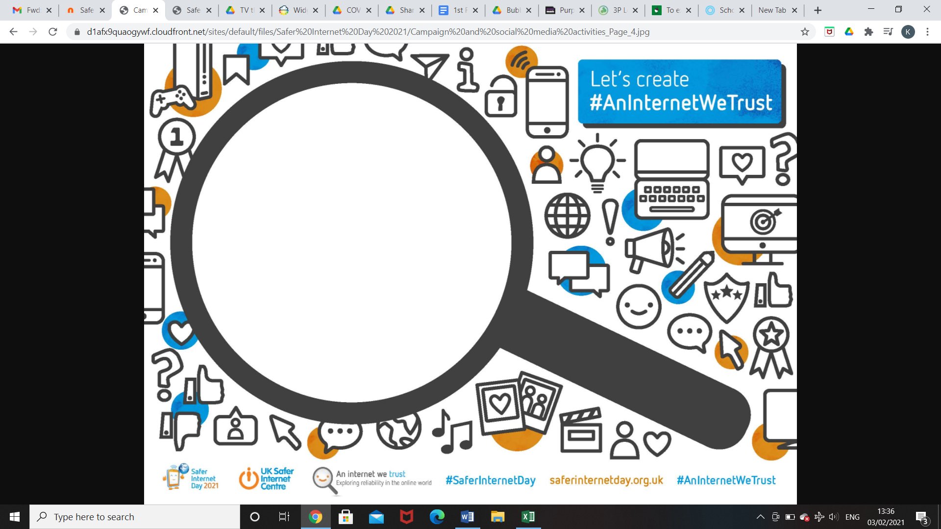

**Fill in the magnifying glass in whatever way you want to**. Ideas you may include are:

● Words or questions we can ask to help us spot if something is reliable online. E.g. Who wrote this? Why was it written?  
● Pictures of what a better, more trustworthy internet could look like. Images of online clues that may make something seem less reliable or trustworthy.  
● Pledges of what you will do to help create a more trustworthy internet, such as, “I will only share things I have checked are true” or “I will support my friends if fake news upsets them.”