20
Meadowside School
Reading Policy
Written: September 2022
Staff Consultation - 30.09.22
Inspiring Brighter Futures
Date policy last reviewed: | Oct 23, January 23

Signed by:
 | Head Teacher | Date: | 7/11/23
 | Chair of Governors | Date:

Contents:
Statement of intent
- Legal framework
Implementation
- Roles and responsibilities
- EYFS
- The curriculum
- Teaching and learning
- Planning
Impact
- Assessment and reporting
- Resources
- Equal opportunities
- Additional reading activities
- Monitoring and reporting

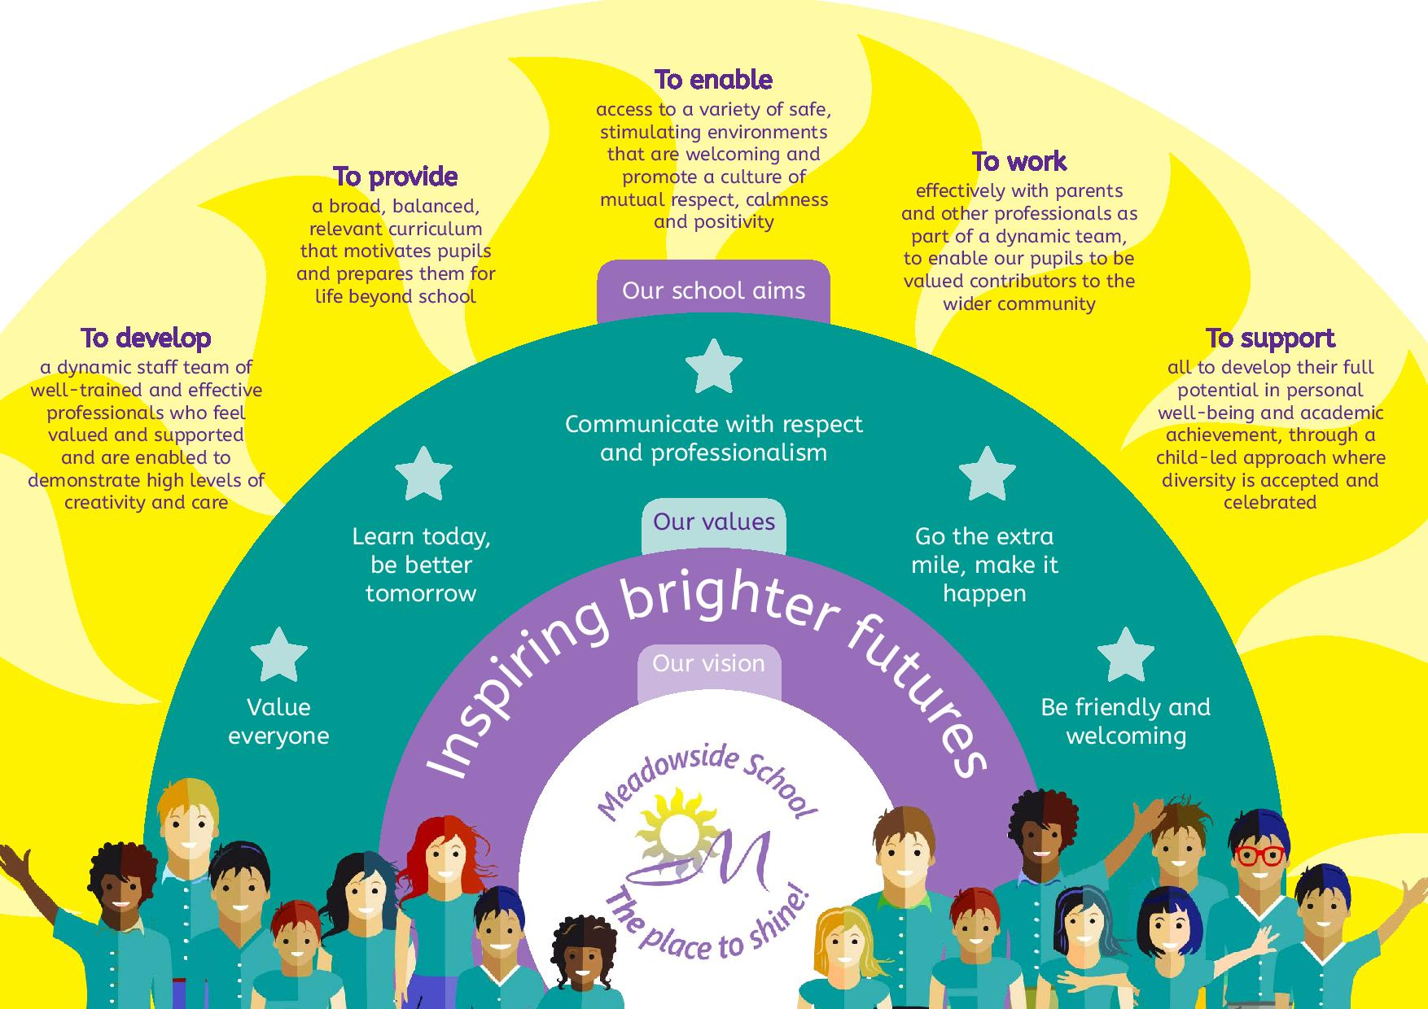

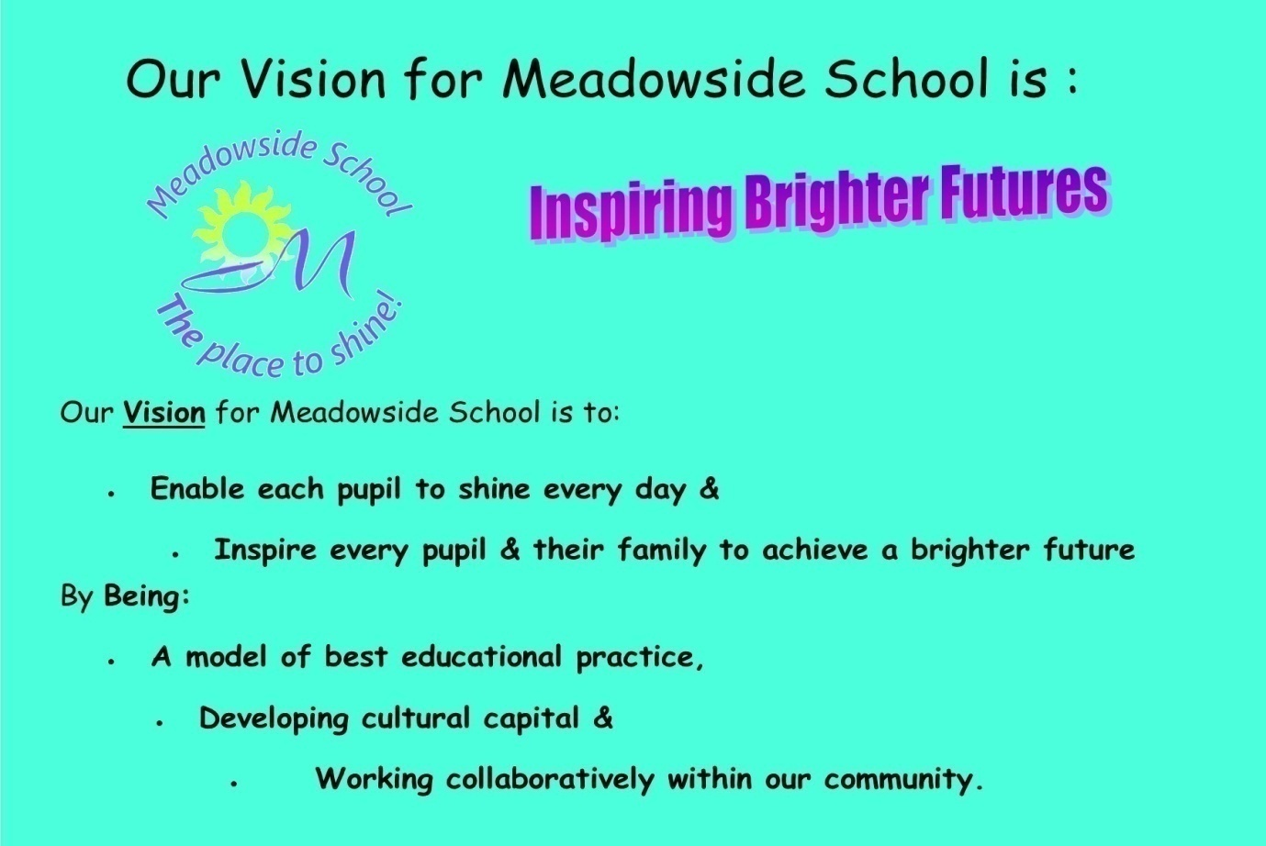

Equality Statement
This policy reflects the Equality Act (2010). The basic principle behind the Act is that it is unlawful to discriminate against a person because of his/her/their:
- Disability
- Age
- Gender
- Race
- Sexual Orientation
- Religion or Belief
- Pregnancy or new motherhood
- Marriage/civil partnership
- Trans-sexuality

This school is committed to the Equality Agenda. We aim to achieve equality of opportunity by challenging and removing direct and indirect discrimination wherever it exists.
We welcome and value the contribution that a diverse community can offer as we aim to:

Treat all people equally according to needs, irrespective of their race, colour, ethnic origin, religion or beliefs, gender, transgender, age, sexual orientation, physical, mental, sensory or learning disability, marital status or economic status or any other factor
Not tolerate harassment or intimidation of any kind and will respond to all reports of harassment/intimidation
Encourage all individuals to apply to us for employment. We value the differences amongst our staff and aim to use their differences in a positive way, towards meeting our vision
Promote the school to parents and prospective pupils, welcoming diversity and offering personalised approaches, needs led, to meet the outcomes aspired to in the child/young person’s EHCP and in accumulating cultural capital in preparation for the choices of adult life
Be committed to ensuring that equality of opportunity underpins all our procedures, policies and work practises, supported with equal opportunities and diversity training for our staff and reinforced across the whole curriculum for our pupils.
If barriers can be overcome, we offer equal opportunities for all, if not then we offer equity of opportunity.
We use a 'total communication' approach to ensure that all pupils can access the lessons – this includes the use of signing, symbols and objects of reference where needed.
All staff have high expectations of all pupils and aim to provide a fully inclusive environment where all pupils can achieve their best.

At Meadowside, we will ensure that people with protected characteristics have the same opportunities as those without. We will not treat a pupil/staff member less favourably than others. We will make all reasonable adjustments to ensure that a pupil or member of staff is not placed at a disadvantage because of the nature of their protected characteristic.

Statement of Intent
Meadowside School understands the importance of reading in the process of developing pupils into independent learners. Reading is central to our ability to understand, interpret and communicate with one another.
The intent of this policy is:
- To instil a passion for reading in pupils, which they will carry on into subsequent learning and their later life.
- To set out the school’s intentions and approach to reading, to enrich and support the curriculum.
- To embed 5 principles to teaching, learning & assessment of reading:
  - Teaching to know the purpose of each activity, share this with pupils, students & support staff to sharpen their focus
  - Teaching is passionate to engage pupils & staff emotionally
  - Teaching is always at an effective pace devoted to learning
  - Ensure every pupil, student can participate
  - Praise effort & progress not ability
- Embed RW Inc. as an effective, consistent routine & system across the curriculum
- Teamwork and consistency being the keys
- Avoid giving the pupils & students bribes to learn to read as our core purpose is to ensure that they want to learn, unless it is an agreed teaching strategy
- Embed positive teaching
- Embed our T, L&A Policy: what more do learners: know, remember & do from the impact of good teaching in preparation for life beyond Meadowside
- Embed the correlation of Blanks’ level questioning with Reading Records
- Embed the correlation of SaLT communication advice and the use of AAC systems with Reading Records

Legal framework

This policy has due regard to all relevant legislation and guidance including, but not limited to, the following:
- DfE (2013) ‘English programmes of study’
- DfE (2021) ‘Statutory framework for the early years foundation stage’
- DfE ‘The Reading Framework – teaching the foundations of literacy July 21, update Jan 22’
This policy operates in conjunction with the following school policies:
- Meadowside Teaching, Learning and Assessment Policy
- Equality, Equity, Diversity and Inclusion Policy

Implementation

Roles and responsibilities
The governing board will be responsible for:
- Ensuring a broad, balanced and relevant reading curriculum is implemented in the school.
- Ensuring the school’s reading curriculum is accessible to all pupils.
The head teacher will be responsible for:
- The overall implementation of this policy.
- Ensuring the school’s reading curriculum is implemented consistently.
- Ensuring appropriate resources are allocated to the reading curriculum.
- Ensuring all pupils are appropriately supported.
- Appointing a member of staff to coordinate on the school’s approach to teaching reading.
The literacy coordinator, alongside the curriculum lead will be responsible for:
- Leading on the school’s approach to reading.
- Preparing curriculum plans and schemes of work for the subject.
- Communicating developments in the subject to all teaching staff and SLT, as appropriate.
Teachers/Lesson Leaders will be responsible for:
- Acting in accordance with this policy.
- Planning lessons effectively, ensuring a range of adaptive teaching methods are used to cover the content of the curriculum.
- Reporting pupil progress
- Liaising with the literacy coordinator about the sequence of topics, resources and support for individual pupils.
- Monitoring the progress of pupils in their class and reporting this on an annual basis to parents.
- Reporting any concerns regarding the teaching of the subject to the subject coordinator or a member of SLT.
- Undertaking any training that is necessary in order to effectively teach reading skills.
The curriculum lead will be responsible for:
- Liaising with the literacy coordinator in order to implement and develop specialist reading-based learning throughout the school.
- Organising and providing training for staff regarding the reading curriculum for pupils with SEND.
- Advising staff how best to support pupils’ needs.

Curriculum Subjects/Learning Domains
All pupils across all 4 curricular will be taught to develop their reading skills as an integral part of the sequenced curriculum covered during the academic year.
All reading intended learning outcomes and teacher expectations will be underpinned by the early cognitive learning objectives (Quest & Semi-Formal) through to NC objectives according to our Meadowside curriculum frameworks & individual EHCPs.
In accordance with comprehension within the early steps of NC teacher expectations will be based on prior achievements & next steps, eg:
- Demonstrate understanding of what has been read to them by retelling stories and narratives using their own words and recently introduced vocabulary.
- Anticipate, where appropriate, key events in stories.
- Use & understand recently introduced vocabulary during discussions about stories, non-fiction, rhymes & poems during role play.
In accordance with word reading, within the early steps of NC teacher expectations will be based on prior achievements & next steps, eg:
- Say a sound for each letter in the alphabet & at least 10 digraphs.
- Read words consistent with their phonic knowledge by sound-blending.
- Read aloud simple sentences & books that are consistent with their phonic knowledge, including some common exception words.

The curriculum
All pupils working within Formal Curriculum content will be taught reading in line with the requirements of the national curriculum:
Firstly, formal learners will be taught:

Word reading
(A grapheme is a written symbol that represents a sound (phoneme). This can be a single letter, or could be a sequence of letters, such as ai, sh, igh, tch etc. So when a child says the sound /t/ this is a phoneme, but when they write the letter 't' this is a grapheme.)

- Apply phonic knowledge and skills to decode words.
- Respond speedily with the correct sound to graphemes (letters or groups of letters) for all phonemes (40+), including, where applicable, alternative sounds for graphemes.
- Read accurately by blending sounds in unfamiliar words containing grapheme-phoneme correspondences (GPCs) that have been taught.
- Read common exception words, noting unusual correspondences between: spelling and sound, and where these occur in the word.
- Read words containing taught GPCs and -s, -es, -ing, -ed, -er, and -est endings.
- Read other words of more than one syllable that contain taught GPCs.
- Read words with contractions, e.g. I’m, I’ll, We’ll, and understand that the apostrophe represents the omitted letter/s.
- Accurately read books aloud that are consistent with their developing phonic knowledge and that do not require them to use other strategies to work out words.
- Re-read these books to build up their fluency and confidence in reading.

All pupils working within Pre-Formal and for some in Semi-Formal Curriculum, content will be taught pre-reading and pre-phonics in line with the frameworks of Quest and WRInc. The Pre-Formal pathway is mainly for those who have Profound and Multiple Learning Difficulties who are unable to access the National Curriculum:

Pre-formal literacy is delivered by teaching staff, embedding it throughout routines of the day. Familiar stories, are explored for a longer period than semi-formal learners (a term, or sometimes longer), to provide context, variety and allows pupils to generalise the skills they are learning and develop their ability to apply them to real life situations.
The stories implemented in the curriculum are planned in a thematic cycle linked to Subject Leaders Long and Medium Term Plans, where possible, to expose learners to a rich variety of sensory experiences and concepts. Activities are built around rhythm and rhyme, sensory play, props, and acting (dressing up as characters). Most pre-formal learners will be working at Phase 1 of phonics, meaning that they are developing their pre-phonic awareness, learning patterns of sound and rhyme through a multisensory approach.
Pre-Formal learners require a higher level of adult support, both for their learning needs and their personal care, and are likely to need sensory stimulation, with their curriculum broken down into very small steps. Some of our Pre-Formal learners communicate by gesture, eye-pointing, and at times very simple language. Pre-formal learners develop their attention, anticipation, listening and communication skills through sensory stories, massage stories, intensive interaction, parallel play, attention building, intervenor work and on-body signing, resonance boards, and TACPAC - all linked to the story topic. Progress made during these interventions is tracked against student’s individual communication targets in their EHCP, the ‘English Curriculum’ framework, Quest framework, Blanks’, Engagement Profile, depending on what is most appropriate for each learner.
Comprehension.

Teaching and Learning comprehension for Learners with PMLD:

Teaching, learning and assessment must consider the effects and implications of multi-sensory impairments (MSI), Autistic Spectrum Disorder (ASD), and other neurological impairments associated with severe and complex learning difficulties, (SCLD,) may have on communication and the barriers to overcome.
Teaching and planning, personalise approaches that practically support the sensory deficits/needs of pupils, known at their current starting point, by;
- Ensure lessons are sensory based and appeal to each child based on their individual starting point.
- Make sure that accessible and reinforcing visual/tactile/auditory/IT/positional aids are in place.
- Have a variety of sensory communication aids, lights, and materials all around the classroom.
- Use consistent vocabulary within all planned routines, pitched to the strategies detailed in individual communication passports/Help Me Sheets/1 Page Pupil Profiles.
- Teach communication as a ‘forever’ life skill, re: promoting an individual’s ability, eg: to have some control over their environment and being empowered to make choices.

Semi and Formal Learners

- Develop pleasure in reading, motivation to read, vocabulary and understanding by:
  - Listening to and discussing a wide range of poems, stories and non-fiction at a level beyond which they can read independently at.
  - Being encouraged to link what they read or hear to their own experiences.
  - Becoming very familiar with key stories, fairy stories and traditional tales, retelling them and considering their particular characteristics.
  - Recognising and joining in with predictable phrases.
  - Learning to appreciate rhymes and poems, and to recite some by heart.
  - Discussing word meanings, linking new meanings to those already known.
- Understand the books they can already read accurately and fluently, and those they listen to by:
  - Drawing on what they already know or on background information and vocabulary provided by the teacher.
  - Checking that the text makes sense to them as they read, and correct inaccurate reading.
  - Discussing the significance of the title and events.
  - Making inferences on the basis of what is being said and done.
  - Predicting what might happen on the basis of what has been read so far.
- Participate in discussion about what is read to them, taking turns and listening to what others say.
- Explain clearly their understanding of what is read to them.

Building on this, pupils will be taught:
Word reading
- Continue to apply phonic knowledge and skills to decode words until automatic decoding has become embedded and reading is fluent.
- Read accurately by blending the sounds in words that contain the graphemes taught so far, especially recognising alternative sounds for graphemes.
- Accurately read words of two or more syllables that contain the graphemes taught so far.
- Read words containing common suffixes.
- Read further common exception words, noting unusual correspondences between spelling and sound and where these occur in the word.
- Read most words quickly and accurately, without overt sounding and blending, when they have been frequently encountered.
- Read aloud books closely matched to their improving phonic knowledge, sounding out unfamiliar words accurately, automatically and without undue hesitation.
- Re-read these books to build up their fluency and confidence in word reading.
Comprehension
- Develop pleasure in reading, motivation to read, vocabulary and understanding by:
  - Listening to, discussing and expressing views about a wide range of contemporary and classic poetry, stories and non-fiction at a level beyond that at which they can read independently.
  - Discussing the sequence of events in books and how items of information are related.
  - Becoming increasingly familiar with and retelling a wide range of stories, fairy stories and traditional tales.
  - Being introduced to non-fiction books that are structured in different ways.
  - Recognising simple recurring literary language in stories and poetry.
  - Discussing and clarifying the meanings of words, linking new meanings to known vocabulary.
  - Discussing their favourite words and phrases.
  - Continuing to build up a repertoire of poems learnt by heart, appreciating these and reciting some, with appropriate intonation to make the meaning clear.
- Understand the books that they can already read accurately and fluently, and those that they listen to by:
  - Drawing on what they already know or on background information and vocabulary provided by the teacher.
  - Checking that the text makes sense to them as they read, and correcting inaccurate reading.
  - Making inferences on the basis of what is being said and done.
  - Answering and asking questions.
  - Predicting what might happen on the basis of what has been read so far.
- Participate in discussion about books, poems and other works that are read to them and those that they can read for themselves, taking turns and listening to what others say.
- Explain and discuss their understanding of books, poems and other material, both those that they listen to and those that they read for themselves.
Beyond this, pupils will be taught:
Word reading
- Apply their growing knowledge of root words, prefixes and suffixes (etymology and morphology) to reading aloud and understanding the meaning of new words they meet.
- Read further exception words, noting the unusual correspondences between spelling and sound, and where these occur in the word.
Comprehension
- Develop positive attitudes to reading, and an understanding of what they read, by:
  - Listening to and discussing a wide range of fiction, poetry, plays, non-fiction and reference books or textbooks.
  - Reading books that are structured in different ways and reading for a range of purposes.
  - Using dictionaries to check the meaning of words that they have read.
  - Increasing their familiarity with a wide range of books, including fairy stories, myths and legends, and retelling some of these orally.
  - Identifying themes and conventions in a wide range of books.
  - Preparing poems and play scripts to read aloud and to perform, showing understanding through intonation, tone, volume and action.
  - Discussing words and phrases that capture the reader’s interest and imagination.
  - Recognising some different forms of poetry, e.g. free verse, narrative poetry.
- Understand what they read, in books they can read independently, by:
  - Checking that the text makes sense to them, discussing their understanding, and explaining the meaning of words in context.
  - Asking questions to improve their understanding of a text.
  - Drawing inferences such as inferring characters’ feelings, thoughts and motives from their actions, and justifying inferences with evidence.
  - Predicting what might happen from details stated and implied.
  - Identifying main ideas drawn from more than one paragraph and summarising these.
  - Identifying how language, structure, and presentation contribute to meaning.
- Retrieve and record information from non-fiction.
- Participate in discussion about both books that are read to them and those they can read for themselves, taking turns and listening to what others say.

Progressing to, pupils will be taught to:
Word reading
- Apply their growing knowledge of root words, prefixes and suffixes (morphology and etymology) to both read aloud and understand the meaning of new words they encounter.
Comprehension
- Maintain positive attitudes to reading and an understanding of what they read by:
  - Continuing to read and discuss an increasingly wide range of fiction, poetry, plays, non-fiction and reference books or textbooks.
  - Reading books that are structured in different ways and reading for a range of purposes.
  - Increasing their familiarity with a wide range of books, including myths, legends and traditional stories, modern fiction, fiction from our literary heritage, and books from other cultures and traditions.
  - Recommending books that they have read to their peers, giving reasons for their choices.
  - Identifying and discussing themes and conventions in and across a wide range of writing.
  - Making comparisons within and across books.
  - Learning a wider range of poetry by heart.
  - Preparing poems and plays to read aloud and to perform, showing understanding through intonation, tone and volume so that the meaning is clear to an audience.
- Understand what they read by:
  - Checking that the book makes sense to them, discussing their understanding and exploring the meaning of words in context.
  - Asking questions to improve their understanding.
  - Drawing inferences such as inferring characters’ feelings, thoughts and motives from their actions, and justifying inferences with evidence.
  - Predicting what might happen from details stated and implied.
  - Summarising the main ideas drawn from more than one paragraph, identifying key details that support the main ideas.
  - Identifying how language, structure and presentation contribute to meaning.
- Discuss and evaluate how authors use language, including figurative language, considering the impact on the reader.
- Distinguish between statements of fact and opinion.
- Retrieve, record and present information from non-fiction.
- Participate in discussions about books that are read to them and those they can read for themselves, building on their own and others’ ideas and challenging views courteously.
- Explain and discuss their understanding of what they have read, including through formal presentations and debates, maintaining a focus on the topic and using notes where necessary.
- Provide reasoned justifications for their views.

Teaching and learning
The reading curriculum will be delivered in line with the school’s Teaching, Learning and Assessment Policy, embedded in our Preparation for Adulthood culture.
The reading curriculum will primarily be delivered during English, literacy, communication and self-regulation lessons; however, reading is to be encouraged in all areas of the curriculum and other learning activities.
On entry to the school, all pupils/students will be assessed to establish their individual starting points, to identify how they best learn and to establish the most well-matched curricular pathway, (Formal, Semi or Pre-Formal), on which to place them.

Assessment will focus on:
- Sound awareness & discrimination
- Use of:
  - Objects of reference
  - Tobis
  - Photos
  - Symbols
  - Letter Sounds
  - Blending & segmenting
  - Reading for comprehension
- Blanks’ level questioning

Accurate assessment will be recorded in EfL & in their individual reading log. This assessment & recording will be ongoing to demonstrate progress. Lateral progress in wider outcomes detailed in the child’s EHCP will be measured using the ALP Tool. Vertical progress in cognition, communication will be tracked using our own subject & learning domain curriculum frameworks.
Parents are encouraged to log in to “Oxford Owl” and support their child’s reading of familiar text. Others may agree for familiar books to be sent home
Reading for pleasure, and/or information is to be encouraged across the curriculum and in all learning activities, regardless of the degree of formalisation of the curriculum that individuals are accessing, or teaching approach used, in a variety of engaging ways, eg: book and bagel, lunchtime downtime, being read to-voice sounds, Makaton, PECs, library, when unable to join in an activity, eg: swim, story massage, sensory stories, “mouthing mirrors”, intensive interaction, audio stories, sub-titles, virtual environments, active learning, body percussion, rhythm and rhyme, alliteration, blending sounds and segmenting words.
Classrooms and corridors must be text rich, using our preferred font of comic sans if computer generated and pupil writing. Designated reading areas should contain appealing books.

Planning
The school will create long-term, medium-term and short-term plans for the delivery of the reading curriculum – these are as follows:
- Long-term: includes the sequence of topics to be studied in each term during the key stage
- Medium-term: includes the details of work to be studied each term
- Short-term: includes the details of work to be studied during each lesson
The Literacy Coordinator and Curriculum Lead will remain responsible for reviewing and updating long-term plans and the Literacy Coordinator: medium-term plans, and communicating these to teachers.
Teachers will remain responsible for reviewing and updating short-term plans, building on the medium-term plans, taking into account pupils’ starting points, next steps, individual needs and identifying the learning opportunities and adaptive teaching approaches in how curriculum content could be taught.
All relevant staff members will be briefed on the school’s planning procedures as part of their staff training.
In the school, reading will be taught both as a discrete lesson and as part of cross-curricular themes where appropriate.
Teachers will consistently follow the school’s reading curriculum when planning relevant lessons and systematically teach RWI methods of phonics with fidelity, to extend their reading vocabulary. Lesson plans will demonstrate a balance of interactive and independent elements used in teaching, ensuring that all pupils engage with their learning.

Assessment and reporting
To quality assure all pupils’ ability to use phonics, assessment will be by one person across the whole school, currently the literacy coordinator and in line with the validated RWI system.
As a Secondary School, the EYFS Profile may prove useful for Teachers to refer to in support of many of our less formal learners. The progress and development of pupils working within the EYFS may be assessed against the ELGs outlined in the ‘Statutory framework for the early years foundation stage’.
Formative and summative assessments will take place throughout the year to assess pupils’ progress in pre-reading and reading, to identify next steps and any support or intervention required.
Parents will be provided with a written report about their child’s progress during the Summer term every year. These will include information on pupils’ attitudes towards reading and understanding of the key concepts.
Verbal reports will be provided at parent-teacher consultation events during the Autumn and Spring terms.
The progress of pupils, all with SEND, will be monitored by: Teachers updating Subject Leads & Pastoral Tutors, so if progress does not meet expectation, then other vulnerabilities will be considered for targeted intervention and support.

Resources
The literacy coordinator will remain responsible for the management and maintenance of reading resources, as well as for liaising with the Curriculum Lead to purchase further resources.
Reading resources will be stored in each classroom. Designated reading areas will present resources in an appealing display.
Display walls will be utilised and updated on a termly basis, in accordance with the curriculum content being taught at the time.
The school library based in Orange Room will contain an array of resources to support pupils’ learning.
The subject leader will undertake an audit of reading resources on an annual basis.

Equal opportunities
The school will actively encourage all pupils to read/listen to books that are suitable for their reading next steps, and this is reflected in the reading materials which are to be used.
The school will ensure that all pupils have equal access to the reading curriculum, in line with our Pupil Equality, Equity, Diversity and Inclusion Policies.
The literacy coordinator and teachers will ensure reading activities are adapted as appropriate to ensure all pupils can access the curriculum.

Additional reading activities
Alongside the set reading curriculum, the school ensures pupils are able to take part in a range of other reading activities, including the following:
- Visits to local libraries
- Celebration of reading-based awareness days, such as World Book Day
- Reading-based extra-curricular activities
- Interactive sensory stories
- Story massage
- Drama
- Reading in Church and in Assemblies
- Job/College Application processes
- Education in the Community: Shopping, visits to museums, places of worship, Nursing Homes

Emergent Reading

Underpinning our phonics system is development of early cognition, communication and social skills. Pre-reading skills are developed to support understanding, transitions, make choices, indicate preferences and communicate intentionally, using the following:
- Objects of Reference: OoR
Objects of reference are consistent objects that can be used to represent an activity person or place. These objects stand for something in the same way that words do. For example, a child may get excited when their coat is put on as they know this means they are going outside. The object is introduced and accompanied by the spoken word at the start of an activity, consistently by staff. The object may be referred to during the learning activity and then, withdrawn at the end.
- TOBIs: True Object based Icons
These are photos that are cut out in the shape of an object. Staff must be consistent with their use and deploy in the same method as OoR. This may be progressed to photographs.
- Use of Symbols
In progression from photos, symbol-based communication may be introduced to pupils/students who are unable to communicate using speech alone and who have not yet developed, or have difficulty developing literacy skills. Symbols offer a visual representation of a word or idea. Consistent use of symbols must be used across school.
Integrating Therapies:
Consistent & systematic use of communication aids used to develop pre-reading skills must be followed by all staff, across the curriculum. Therapeutic approaches to teaching must be embedded to assist all pupils to develop their auditory awareness, discrimination and speech sound systems, by being consistently embedded into practice. Designated time has been scheduled for advices from health colleagues to be followed including: SaLT, HI, VI, Physio, OT, Sensory Integration OT to promote discrimination of sounds.
Support systems to facilitate intentional communication can be used on visual schedules and timetables, for personal organisation and planning, Now and Next Boards, communication boards/story boards and books, matching activities or in day to day communication.
Systems to be embedded would include AAC programmes, positioning, self-regulation, optimised use of hearing, speech & visual aids, relevant to meet the needs of our pupils/students. An embedded Total Communication Environment and the consistent stimulation of all senses: proprioception, interoception, taste, olfactory, touch, auditory and visual, must be in balance to optimise sensory awareness and discrimination to develop neural pathways reinforcing early development of cognition, communication and social skills. The delivery of best practice must be embedded, and used consistently by all staff, without exception.
- Auditory Awareness and Discrimination (Ref: Wellbeing Family: Ann Logsdon 2021)
Auditory awareness can be assessed through pupil responses and tracking to sound. “Auditory discrimination is the ability to recognize similarities and differences between sounds.
Particularly, auditory discrimination allows people to distinguish between phonemes in words. Phonemes are the smallest units of sound in any given language. Auditory discrimination allows a person to tell the difference between words and sounds that are similar, as well as words and sounds that are different.
Children with auditory discrimination challenges may have trouble remembering sequences of words and may write words incorrectly as well,...widely known as an auditory processing disorder, (APD). ”Most neurotypical.... “people don't even have to think about the differences between sounds. It's something the brain automatically does. In people with APD, there's a malfunction of sorts, that occurs that prevents them from discriminating between phonemes. Children with these disorders are usually not hearing impaired. They just have differences detecting the subtleties in the sounds of words. An auditory discrimination problem may be found if the child has lasting problems with language and reading”.... Early intervention is based on consistently, embedded school wide systems, as these are key to support ... these children”....before ”it can derail their progress in and outside of school, given that auditory discrimination is necessary for all aspects of one's life”.
We can define auditory awareness, when pupils/students respond to sounds, then auditory discrimination as they respond to different environmental sounds, instrumental sounds, lilt, rhyme & rhythm, letter sounds, oral blending and decoding words, spelling, to comprehension.
Reading at home
Parental involvement and encouragement plays a crucial part in pupils’ reading development and the school will promote a home-school reading partnership by:
- Communicating with parents and sharing information with them through parent workshops, newsletters, dojos, home school books, Meadowside Magazine and progress consultation events.
- Giving pupils a book to read at home each day to reinforce the skills they have learned during guided reading.
- Encouraging parents to make notes in the pupils’ reading logs about reading progress made at home.
Pupils are encouraged to read at home through the following methods:
- Family learning sessions after school and during school holidays
- After school meetings with parents
- Book swaps
- Notifications for parents informing them of their child’s progress
Remote learning opportunities are enhanced by electronic home access to “Oxford Owl”

Monitoring and review
This policy will be reviewed on an annual basis by the literacy coordinator, curriculum lead and the head teacher. The next scheduled review of this policy is September 2023. Any changes made to this policy will be communicated to all teaching staff and other key stakeholders.

Related Policy:
KCSiE 2023
Meadowside T, L&A Policy, Meadowside English Policy, & Meadowside Tiered Curriculum Progression Model of Reading & Menu of Adaptive Teaching Approaches Responsive to Pupil Need.
Safeguarding & e-safety Policies
Display Policy
PfA Culture
Scarborough H 2001 Connecting early language & later literacy to later reading (dis)abilities: Evidence, theory, & practice. Pp. 97-110: S B Neuman & D K Dickenson (Eds.) Handbook of early literacy. NY: Guildford Press

The Reading Rope
Dr. Hollis Scarborough compares skilled reading to the many strands of a rope. Each strand represents a separate skill that when combined with the others, creates a strong, proficient reader. When any one strand (skill) is not acquired with fluency, it weakens the strength of the rope. Scarborough’s model depicts each skill as a strand woven together to form either language comprehension and word recognition, and then those two woven together to form skilled reading (reading comprehension). Students must receive instruction that supports all of these skills in order to develop into a skilled reader. (Hennessey. Oct. 12, 2020)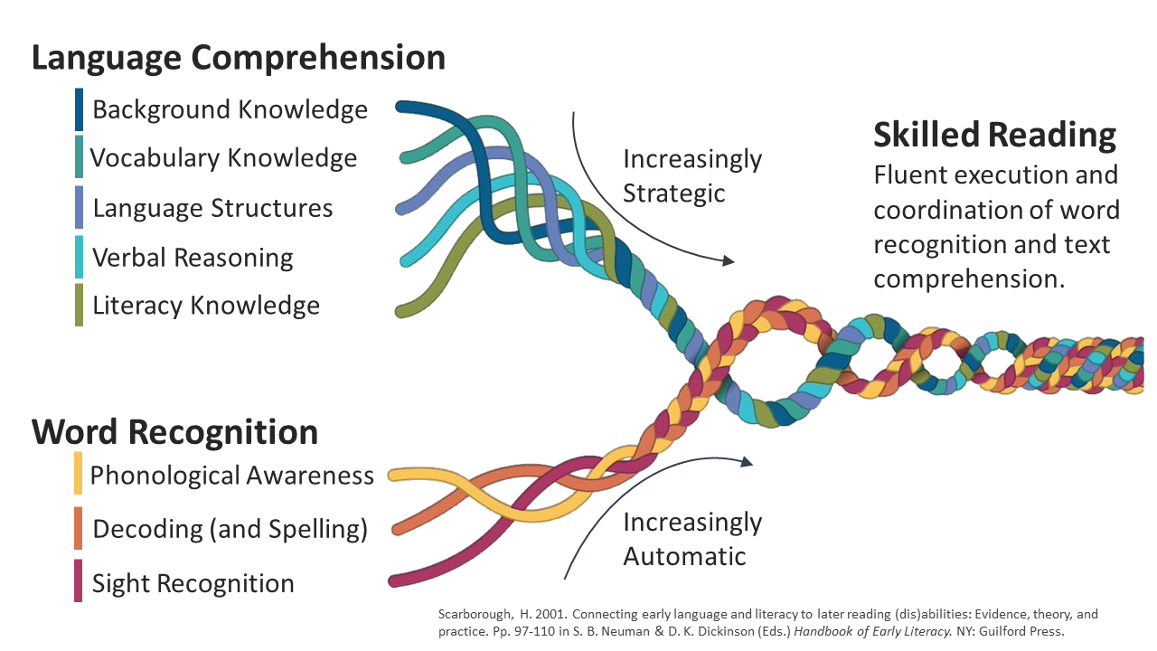Lower Reading Rope – The Word-Recognition Strands:
Phonological awareness, decoding, and sight recognition of familiar words work together as the reader becomes accurate, fluent, and increasingly automatic with repetition and practice.
Upper Reading Rope – Language Comprehension Strands:
Once readers have mastered word recognition, the dominant factor contributing to proficient reading comprehension is language comprehension ability. This is the ability to simultaneously integrate and organize information from various language systems into a single meaningful representation.
All the strands of Scarborough’s Reading Rope are interdependent and develop over time. The lower strands require increasing automaticity; whereas, the upper strands require readers to become increasingly strategic in the use and integration of their ever-growing language abilities.

Inspiring Brighter Futures
MEADOWSIDE SCHOOL WORKLOAD IMPACT ASSESSMENT 2022-3: Implementing new proposals or initiatives:
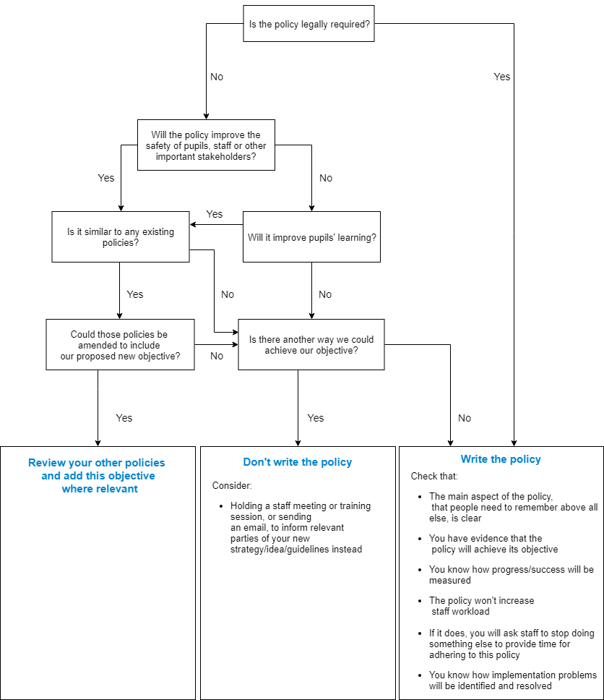
Ensuring staff have capacity to take on a new task is vital to its success and their wellbeing. Our aim is to put the joy back into teaching without compromising pupil outcomes: Suggested Policy: Reading Policy

- Embedding consistency
- Yes
- Yes
- Yes
Summing Up & Judgement:
- Best Practice
- Accountability of FGB, staff, pupils
- Yes PfA
- Write Policy

“Any Critical Incident
Flow Charts: collate into
Incident Protocols
Folder, in Office”

