29

Meadowside School
RSE Policy
Written: Claire Dunn
Author: February 2024

For Consultation

Signed by:
 | Head Teacher | Date:
 | Chair of Governors | Date:
Review date: | Reviewed by:

Contents

Meadowside School Vision, Values & Aims 3
Equality Statement 4
Statement of Intent 5
1. Legal Framework 6
Implementation 6
2. Roles and responsibilities 6
3. Curriculum Subjects/Learning Domains 7
4. The curriculum 7
5. Teaching and Learning 9
6. Planning 9
Impact 9
7. Assessment and Reporting 9
8. Resources 10
9. Equal opportunities 10
10. Monitoring and Review 10
Appendices 11
MEADOWSIDE SCHOOL WORKLOAD IMPACT ASSESSMENT 12

Meadowside School Vision, Values & Aims
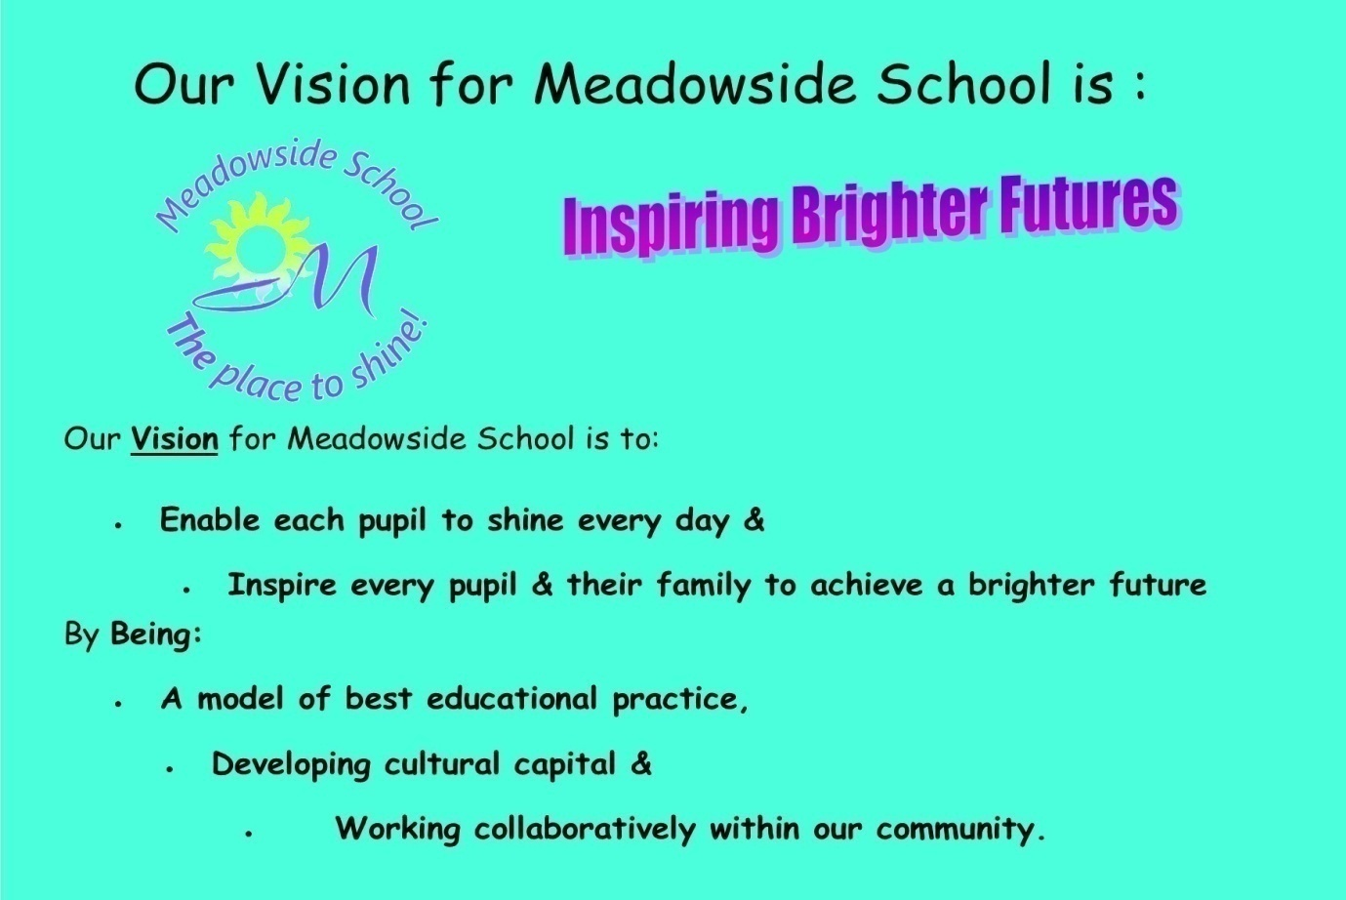
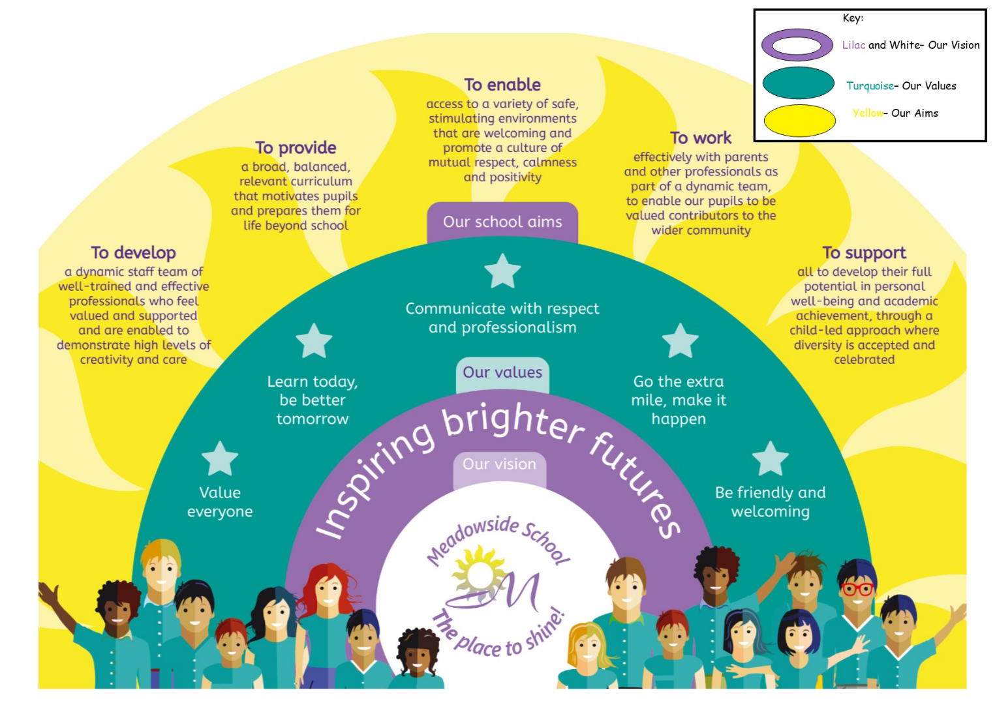

Equality Statement
This policy reflects the Equality Act (2010). The basic principle behind the Act is that it is unlawful to discriminate against a person because of his/her/their:
- Disability
- Age
- Gender
- Race
- Sexual Orientation
- Religion or Belief
- Pregnancy or new motherhood
- Marriage/civil partnership
- Trans-sexuality

This school is committed to the Equality Agenda. We aim to achieve equality of opportunity by challenging and removing direct and indirect discrimination wherever it exists.
We welcome and value the contribution that a diverse community can offer as we aim to:

Treat all people equally according to needs, irrespective of their race, colour, ethnic origin, religion or beliefs, gender, transgender, age, sexual orientation, physical, mental, sensory or learning disability, marital status or economic status or any other factor
Not tolerate harassment or intimidation of any kind and will respond to all reports of harassment/intimidation
Encourage all individuals to apply to us for employment. We value the differences amongst our staff and aim to use their differences in a positive way, towards meeting our vision
Promote the school to parents and prospective pupils, welcoming diversity and offering personalised approaches, needs led, to meet the outcomes aspired to in the child/young person’s EHCP and in accumulating cultural capital in preparation for the choices of adult life
Be committed to ensuring that equality of opportunity underpins all our procedures, policies and work practises, supported with equal opportunities and diversity training for our staff and reinforced across the whole curriculum for our pupils.
If barriers can be overcome, we offer equal opportunities for all, if not then we offer equity of opportunity.
We use a 'total communication' approach to ensure that all pupils can access the lessons – this includes the use of signing, symbols and objects of reference where needed.
All staff have high expectations of all pupils and aim to provide a fully inclusive environment where all pupils can achieve their best.

At Meadowside, we will ensure that people with protected characteristics have the same opportunities as those without. We will not treat a pupil/staff member less favourably than others. We will make all reasonable adjustments to ensure that a pupil or member of staff is not placed at a disadvantage because of the nature of their protected characteristic.

Statement of Intent

All secondary schools are required to teach Relationship and Sex Education, and Health Education. The purpose of this policy is to give information on how it is taught to all members of the school community and any other interested parties.
At Meadowside School, we understand the importance of educating pupils about relationships, sex and health so that they can make responsible and well-informed decisions in their lives.
The teaching of RSHE can help to prepare pupils for the opportunities, responsibilities and experiences of adult life. It allows us to promote the spiritual, moral, social, cultural, mental and physical development of pupils at school and in the wider society.
We have an obligation to provide pupils with high-quality, well-evidenced and age-appropriate teaching of these subjects. This policy outlines how the school’s RSHE curriculum is organised and delivered, to ensure it meets the needs of all pupils.

The Government has made RSE a statutory part of the Curriculum and we agree that it is a crucial part of the curriculum offer. Although the inclusion of RSE is statutory, the DfE has not issued an RSE curriculum. It does, however, specify the key areas to be covered at Secondary age these are:
Families | Respectful relationships incl. friendships | Online & Media | Being Safe | Intimate + Sexual Relationships incl. sexual Health
The law, in relation to a wide range of matters incl. marriage, consent & FGM. | Physical Health & Mental Wellbeing | Internet Safety & Harms | Physical Health & Fitness | Healthy Eating
Drugs, Alcohol & Tobacco | Health & Prevention | Basic First Aid | Changing Adolescent Body | Menstruation

With this freedom it is possible to ensure that RSE at Meadowside is taught in the most relevant, accessible & engaging way to all pupils, regardless of the Curriculum Pathway they access. The PSHE/SRE Education Lead at Meadowside is best placed to design & sequence the curriculum for RSE specified by the DfE, as those which must be covered, & monitor its delivery across the curriculum.

Legal Framework

This policy has due regard to all relevant legislation and guidance including, but not limited to, the following:
- Equality Act 2010
- Children and Social Work Act 2017
- The Relationships Education, Relationships and Sex Education and Health Education (England) Regulations 2019
- DfE (2015) ‘National curriculum in England: science programmes of study’
- DfE (2019) ‘Relationships Education, Relationships and Sex Education (RSE) and Health Education’
- DfE (2021) ‘Teaching about relationships, sex and health’
- [Updated] DfE (2023) ‘Keeping children safe in education 2023’

This policy operates in conjunction with the following school policies:
- Curriculum Planning
- Teaching, Learning & Assessment
- Digital Safety
- Behaviour Policy
- Equalities Statement
- Anti-bullying Policy
- Child Protection and Safeguarding Policy
- Child-on-child Abuse Policy
- GDPR
- Records Management Policy
- Device and Technology Acceptable Use Agreement for Pupils

The Right to Withdraw Children & Young People from Sex Education

We hope that parents/carers will support this aspect of their child’s education, & the understanding of the changes happening to their bodies. We will inform parents of what we are teaching children & when. As of September 2020, parents have the right to request that their child is withdrawn from some, or all, of the sex education delivered as part of statutory RSE, & other than in exceptional circumstances this request will be granted. However, prior to the request being granted, the family will be invited to discuss their request with the Head Teacher, where concerns will be discussed alongside any pros & cons. However, 3 terms prior to their 16th birthday, the young person has the right to opt in to sex education regardless of their parent’s wishes.

Implementation

Roles & responsibilities

The Governing Board will be responsible for:
- Monitoring that all pupils achieve the high expectation set, in making progress in PSHE/SRE Education
- Challenging the PSHE/SRE Education Coordinator that the RSE curriculum is well-led, effectively managed and well-planned.
- Evaluating the quality of provision through regular and effective self-evaluation.
- Ensuring that adaptive teaching is delivered in ways that are accessible to all pupils.
- Providing clear information to parents on the subject content and the right to request that their child is withdrawn.
- Ensuring RSE is resourced in a way that ensures the school can fulfil its legal obligations.
- Ensuring that all teaching staff receive ongoing training on issues relating to PSHSRE Education and how to deliver lessons on such issues.
- Ensuring that they and all staff are up to date with policy changes, and familiar with school policy and guidance relating to RSE.
The Head Teacher & Deputies will be responsible for:
- The overall implementation of this policy.
- Monitoring the impact of teaching, learning & assessment in RSE.
- Making funding available for the necessary training & resources.
- Ensuring all teaching staff are suitably trained to deliver the subjects.
- Ensuring there is adequate time on the school timetable to deliver RSE as a statutory curriculum subject.
- Ensuring parents are fully informed of this policy.
- Reviewing all requests to withdraw pupils from non-statutory elements of the RSE curriculum.
- Discussing withdrawal requests with parents, and the pupil if appropriate, to ensure their wishes are understood and to clarify the nature and purpose of the curriculum, including the benefits of receiving the education.
- Ensuring withdrawn pupils receive appropriate, purposeful education during the period of withdrawal.
- Encouraging parents to be involved in consultations regarding reviews of the school’s RSE curriculum.
- Reviewing this policy on an annual basis.
- Reporting to the governing board on the effectiveness of this policy and the curriculum.

The PSHE/SRE Education Coordinator, alongside the curriculum lead for PfA, will be responsible for:
- Overseeing the delivery of RSE, by providing:
  - long & medium term plans for use by lesson leaders across all curriculum areas.
  - posting detailed knowledge organisers for all curriculum areas & formalisations.
  - appropriate updates on the school website.
- Working collaboratively with colleagues in related curriculum areas to ensure the RSE curriculum complements, the content covered in other curriculum subjects and they reinforce risk-management in PfA.
- Ensuring the curriculum is age and stage appropriate, inclusive, and high-quality.
- Reviewing changes to the RSE curriculum and advising on implementation.
- Monitoring the learning and adaptive teaching of RSE, providing support to staff where necessary.
- Ensuring continuity by sequence and progression is interleaved.
- Helping to develop colleagues’ expertise in the subject.
- Ensuring teachers are provided with adequate resources to support teaching of the curriculum.
- Ensuring the school meets its statutory requirements in relation to RSE.
- Leading staff meetings and ensuring all members of staff involved in the curriculum have received the appropriate training.
- Organising, providing and monitoring CPD opportunities in the subject.
- Ensuring the correct standards are met for recording and assessing pupil performance.
- Monitoring and evaluating the effectiveness of the subjects and providing reports to the head teacher.
- Ensuring parents/carers are informed about key areas of the curriculum, and when certain aspects will be taught.
- Meeting with parents/carers to discuss any concerns they may have (& escalating concerns to the Head Teacher where these cannot be resolved).
- Setting targets with high expectation & monitoring progress.
- Monitoring the coverage of the statutory RSE topics across relevant curriculum areas/learning domains.*
* As many of the content areas for RSE are reinforced in other subjects/learning domains, the Subject Coordinators for Science, Computing, Careers, Citizenship, PE & Life Skills are key to the effective delivery of RSE

The DSL team will be responsible for:
- Offering advice and consultation for safeguarding-related subjects in the RSE curriculum.
- Promoting knowledge and awareness of safeguarding issues amongst staff.
- Being an appropriate point of contact for staff who have concerns about the welfare of a pupil that have arisen through the teaching of RSE.
- Organising a safe space for pupils to go should they need additional support or time to talk after an RSE session.
- Ensuring staff teach in a trauma-informed manner and are particularly mindful of more vulnerable pupils who may have Adverse Childhood Experiences or potential triggers related to the material.

Teachers/Lesson Leaders will be responsible for:
- Acting in accordance with, and promoting, this policy.
- Delivering RSE in a manner that is sensitive, of high quality and age/stage appropriate.
- Ensuring they do not express personal views or beliefs when delivering the curriculum.
- Planning lessons effectively, ensuring a range of adaptive, appropriate, teaching methods and resources are used to cover the content.
- Modelling positive attitudes to RSE.
- Liaising with the Pastoral Tutors to identify and personalise support in response to individual needs of pupils.
- Liaising with the RSE subject coordinator on key topics, resources.
- Monitoring pupil progress in RSE.
- Reporting any concerns regarding the teaching of RSE to the RSE subject leader or a member of SLT.
- Reporting any safeguarding concerns or disclosures that pupils may make as a result of the subject content to the DSL.
- Providing an inclusive approach to their lesson delivery.
- Responding appropriately to pupils whose parents have requested to withdraw them from non-statutory components of RSE, by providing them with alternative education opportunities.
- Implementing the sequence of teaching, in accordance with this policy.
- Ensuring there is high quality evidence of pupil progress.
- Engaging with the Subject Coordinator on monitoring & QA activities.

The Curriculum & Pastoral Lead will be responsible for:
- Keeping this policy up to date
- Consulting & sharing information about the nature & content of the RSE Curriculum with parents/carers.
- Monitoring the impact of teaching, learning & assessment in this area.

Curriculum Subjects/Learning Domains Connections
RSE content is connected through Sc, Careers, CZ, PE, PHSE Ed, Life Skills, & Computing Curricula, being pitched at an appropriate Starting Point & with accessibility, through adaptive teaching of Pre, Semi & Formal learning domains/curricula.

Pastoral Tutors will be responsible for:
- Advising teaching staff how best to identify and support pupils’ individual needs.
- Advising staff on the use of TAs/specialist advice/resources in order to meet pupils’ individual needs.

The curriculum
DfE does not specify a discrete RSE curriculum but recognises how the key content can & is taught naturally, across a wide range of other subject areas/learning domains.
- In this Policy: “RSE” refers to relationships and sex education and is defined as teaching pupils about developing healthy, nurturing relationships of all kinds, and helping them to understand human sexuality and to respect themselves and others.
Our intent for RSE is to teach learners to develop the skills to make positive, caring respectful & healthy relationships. This key to their friendships, within their families & with peers/ adults, to recognise what a healthy relationship looks like, who to trust, who not to trust, how to judge when a relationship is making them unhappy or uncomfortable, manage conflict, & know how to manage these situations, seek help & advice from others where required. Through RSE, learners will develop the skills & knowledge required to help them to safely navigate both the virtual, & real world.
RSE focuses on teaching children & young people to develop the knowledge they need to understand their own bodies, understand how & why it changes, the different aspects of growing up & sexual health. Effective RSE does not encourage early sexual experimentation. It teaches young people, to understand human sexuality, including LGBTQ+ related matters, & to respect themselves & others. It enables young people to mature, build confidence & self- esteem in an environment which is informed, free of bias & the skewed lens of social media.
- In this Policy: “Health education” is defined as teaching pupils about how they can make good decisions about their own health and wellbeing, and how physical health and mental wellbeing are interlinked.
Across PHSE Education & RSE, pupils learn about physical, emotional & mental health. We want to empower our learners through adaptive teaching to look after their bodies, know how to prevent disease, protect themselves from harm & ask for help if they need it. They learn this information through the following units in the following subjects:
Science | PHSE Ed | PE | Citizenship | Life Skills | Computing
-Nutrition & Digestion  -Health  -Reproduction | - Drugs  - Puberty  - Physical & Mental Health  - Awareness of Others  -Hygiene & the Body  - Consent  -First Aid  - Perceptions of What our Bodies Should Look Like. | - Health & Fitness | - Law & Order  - Rights & Responsibilities  - Communities & Cultures | -Healthy Lifestyles: - Food  - Personal Care  - Food & Nutrition  -The Home- Accidents & Prevention  -Clothing | -Digital Literacy & Creativity  -Digital Citizenship

Teaching and Learning
RSE focuses on teaching young people to develop the skills & knowledge they need to develop meaningful & healthy relationships with themselves & with others. Pupils will learn about changes to their bodies, aspects of growing up, sexual health & human sexuality. Effective RSE does not encourage early sexual experimentation, it should teach young people to understand human sexuality & to respect themselves & others.

A small number of pupils may need to access personalised support and this need will be assessed individually, in consultation with the child, their parents/carers and the school staff who know them best. Adaptive teaching will focus on specific areas of need and will be delivered by the most appropriate person, who may not always be the class teacher. Examples of when someone may need a tailored package may include, but is not limited to:
- Support to understand masturbation and how to manage this safely and in appropriate places.
- Sexually dangerous or risky behaviour which places the young person or others at risk.
- Self-injurious behaviour related to sexual exploration.
- Obsessive or fixated behaviour which presents risk to self or others.
- Support for the management of menstruation.
Throughout school life, but specifically within RSE lessons, staff model the use of correct terminology from the start of the school journey. It is important that learners hear the correct words so that they have the vocabulary required to equip them for life. Pupils requiring AAC will also have access to the appropriate terminology. We are committed to working with families to understand home EAL, culture and family perspectives on agreed use of language in the home setting.

Teaching includes sufficient & well-chosen opportunities & contexts for pupils to embed new knowledge so that it can be used confidently in real-life situations.

Planning
In Meadowside RSE is to be delivered in a cross curricular way & is included in the planning for a wide range of subjects. This planning is carried out in line with the Meadowside Curriculum Planning policy. The school will ensure that the curriculum remains in line with DfE’s ‘Relationships Education, Relationships & Sex Education (RSE) & Health Education’ guidance at all times.
School will consider the context & views of the wider local community when developing the curriculum to ensure it is reflective of circumstances in the local area. The religious background of all pupils will also be considered when planning teaching, to ensure all topics included are appropriately & sensitively handled. Our RSE curriculum will be informed by topical issues in school, to ensure it is tailored to pupils’ needs.

We will integrate LGBTQ+ content into the RSE curriculum – this content will be taught as part of the overall curriculum, rather than a standalone topic or lesson. LGBTQ+ content will be approached in a sensitive, age/stage-appropriate & factual way that allows pupils to explore gender identity, stereotypes, & the features of stable & healthy same-sex relationships. All pupils are expected to learn about LGBTQ+ content, & parents do not have a statutory right to withdraw their children from lessons that include LGBTQ+ content.

All teaching & resources will be assessed by the RSE subject coordinator to ensure they are appropriate for the age & maturity of pupils, are sensitive to their religious backgrounds & meet the needs of all pupils with SEND.
Appropriate diagrams, videos, books, games, discussion & practical activities will be used to assist learning. Inappropriate images, videos, etc., will not be used. Pupils will be prevented from accessing inappropriate materials on the internet when using such to assist with their learning. Prevention measures taken to ensure this are outlined in the school’s Online Safety Policy, & the Devices & Technology Acceptable Use Agreement for Pupils.
Teachers will establish what is appropriate for one-to-one & whole-class settings, & adapt their teaching accordingly. Pupils’ views are to be listened to & they will be encouraged to ask questions & engage in discussion. Teachers will answer questions sensitively & honestly.
In teaching the curriculum, teachers will be aware that pupils may raise topics such as single-parent families, self-harm & suicide. When talking about these topics in lessons, teachers will be aware of the risks of encouraging these behaviours & will avoid any resources or material that appear as instructive rather than preventative.
Teachers will ensure lesson plans focus on challenging perceived views of pupils based on protected characteristics, through exploration of, & developing mutual respect for, those different to themselves.
The procedures for assessing pupil progress are outlined in the ‘Assessment’ section of this policy.

RSE continues to develop pupils’ knowledge on topics taught at a primary, in addition to:
Families
- There are different types of committed, stable relationships.
- How relationships contribute to human happiness & their importance for bringing up children.
- What marriage is, its legal status, e.g. marriage brings legal rights & protections not available to couples cohabiting or who have married, eg: in an unregistered religious ceremony.
- Marriage is an important relationship choice for couples & why it must be freely entered into.
- Characteristics & legal status of other types of long-term relationships.
- Roles & responsibilities of parents with respect to raising children, including the characteristics of successful parenting.
Pupils will also learn how to:
- Determine whether other children, adults or sources of information are trustworthy.
- Judge when a family, friend, intimate or other relationship is unsafe, & recognise this in others’ relationships.
- Seek help or advice if needed, including reporting concerns about others.
Respectful relationships, including friendships:
- Characteristics of positive & healthy friendships in all contexts (including online), including trust, respect, honesty, kindness, generosity, boundaries, privacy, & consent; & the management of conflict, reconciliation & ending relationships. This includes different (non-sexual) types of relationships.
- Practical steps they can take in a range of different contexts to improve or support respectful relationships.
- How stereotypes, particularly those based on sex, gender, race, religion, sexual orientation or disability, can cause damage, e.g. how they might normalise non-consensual behaviour.
- That in school & wider society they can expect to be treated with respect by others, & that in turn they should show due respect to others, including people in positions of authority, & show tolerance of other people’s beliefs.
- Different types of bullying (including cyberbullying), the impact of bullying, responsibilities of bystanders to report bullying, & how / where to seek help.
- Types of behaviour in relationships that can be criminal, including violent behaviour & coercive control.
What constitutes sexual harassment & violence & why these are always unacceptable.
The legal rights & responsibilities regarding equality, with reference to the protected characteristics defined in the Equality Act 2010, & that everyone is unique & equal.
Online and media:
- Rights, responsibilities & opportunities online, & that the same expectations of behaviour apply in all contexts.
- Online risks, including: material shared with another person has the potential to be shared online & the difficulty of removing potentially compromising material placed online.
- Not to provide material to others that they would not want shared further & not to share personal material which they receive.
- What to do & where to get support to report material or manage issues online.
- Impact of viewing harmful content.
- Specifically, sexually explicit material, e.g. pornography, presents a distorted picture of sexual behaviours, can damage the way people see themselves in relation to others & negatively affect how they behave towards sexual partners.
- Sharing & viewing indecent images of children is a criminal offence which carries severe penalties, including imprisonment.
- How information & data is generated, collected, shared & used online.
Being safe
- About the concepts of, & laws relating to, sexual consent, sexual exploitation, abuse, grooming, coercion, harassment, rape, domestic abuse, forced marriage, honour-based violence & FGM, & how these can affect current & future relationships.
- How people can actively communicate & recognise consent from others, including sexual consent, & how & when consent can be withdrawn – this includes online.
Intimate & sexual relationships, including sexual health
- How to recognise characteristics & positive aspects of healthy one-to-one intimate relationships, which include mutual respect, consent, loyalty, trust, shared interests & outlooks, sex, & friendship.
- All aspects of health can be affected by choices they make in sex & relationships, positively & negatively, e.g. physical, emotional, mental, sexual, & reproductive health & wellbeing.
- Facts about reproductive health, including fertility & potential impact of lifestyle on fertility for both men & women.
- Range of strategies for identifying & managing sexual pressure, including understanding peer pressure, resisting pressure & not pressurising others.
- Their choice to delay sex or enjoy intimacy without sex.
- Facts about full range of contraceptive choices, their effectiveness, the options available.
- Facts around pregnancy, including miscarriage.
- Choices in relation to pregnancy, with legally & medically accurate impartial information on all options, including parenthood, adoption, abortion & where to get further help.
- How different sexually transmitted infections (STIs) are transmitted, how risk can be reduced through safer sex & the importance of facts about testing.
- The prevalence of some STIs, the impact they can have on those who contract them & key facts about treatment.
- How use of alcohol & drugs can lead to risky sexual behaviour.
- How to get further advice, including how & where to access confidential sexual & reproductive health advice & treatment.
Internet safety and harms
- Similarities & differences between the online world & the physical world, including the impact of unhealthy or obsessive comparison with others online, over-reliance on online relationships, the risks related to online gambling, how information is targeted at them, & how to be a discerning consumer of information online.
- How to identify harmful behaviours online, including bullying, abuse or harassment, & how to report or find support if they have been affected by those behaviours.
Changing adolescent body
- Key facts about puberty, the changing adolescent body & menstrual wellbeing.
- About the main changes which take place in males & females, & the implications for emotional & physical health.
Impact

Assessment and Reporting
The school will have the same high expectations of high quality of pupils’ work in RSE as for other curriculum areas. Lessons will be planned to provide suitable challenge to pupils of all abilities.
The RSE subject coordinator will be responsible for monitoring the quality of teaching & learning for the subject. They will conduct subject assessments on a termly basis, which will include a mixture of the following:
- Self-evaluations
- Lesson observations
- Topic feedback
- Learning walks
- Work scrutiny
- Lesson planning scrutiny
RSE subject coordinator will create annual subject reports for head teacher, governing board & parents, to report on the quality of the subjects. They will also work regularly & consistently with the deputy head teacher, (PfA) & RSE link governor, e.g. through monthly review meetings, to evaluate the effectiveness of the subjects & implement any changes.

Pupils’ progress in RSE is assessed termly using Meadowside’s PSHE Ed/SRE assessment framework, accreditation standards, other subject frameworks, as well as QUEST or MAPP, depending on the pathway the pupil is on. Progress in this area can also be assessed against EHCP outcomes in some cases.

Our revised PSHE Ed programme of study, reinforces WHY? we teach increasing independence, risk management, informed decision making & Personal Safety, in PfA, across all 4 formalisations of the curriculum, with equal learning opportunities, that enables progress across 3 Core themes: ‘Health & Wellbeing’, ‘Relationships’ & ‘Living in the Wider World’.

Progress in RSE is reported under the headings of PSHE Education, Science, Computing, Citizenship, PE, Communication & Social Relationships, Self- Determination & Independence, Wellbeing & Physical, & Myself & My Body.

Training & Resources
Resources to support delivery of RSE are available from the PSHE Education Co-ordinator, and a range of other subject leaders, who manage the budgets for these. Suitable resources may also be available from HSIS or the school nurse.
Training will be provided by the RSE subject leader to the relevant members of staff on a termly basis to ensure they are up-to-date with the RSE curriculum. Training will also be scheduled around any updated guidance on the curriculum and any new developments, e.g. “sexting”, which may need to be addressed in relation to the curriculum.

Equal opportunities
This RSE Policy should be read alongside other relevant Meadowside School policies. It has been written with the 2010 Equalities Act (and its March 20 updates) in mind. Pupils at Meadowside School are treated with consistency and high standards are expected of all. In order to achieve these for all pupils, they are treated with sensitivity towards their individual needs, characteristics and rights. We recognise that treating people equally does not mean treating them in the same way.

Monitoring and Review
At all points of delivery of the curriculum, parents will be consulted, & their views will be valued. What will be taught & how, will be planned in conjunction with parents, ie:
- Curriculum content, including what will be taught and when.
- Examples of resources the school intends to use to deliver the curriculum.
- Information about parents’ right to withdraw their child from non-statutory elements of RSHE.
Pupils who are withdrawn from sex education will receive appropriate, purposeful education during the full period of withdrawal.

This policy will be reviewed on an annual basis by the DHT, (PfA), RSE Coordinator & the HT. The next scheduled review of this policy is March 25. Any changes made to this policy will be implemented & communicated to all teaching staff, parents and other key stakeholders.

Appendices


MEADOWSIDE SCHOOL WORKLOAD IMPACT ASSESSMENT

Implementing new proposals or initiatives:
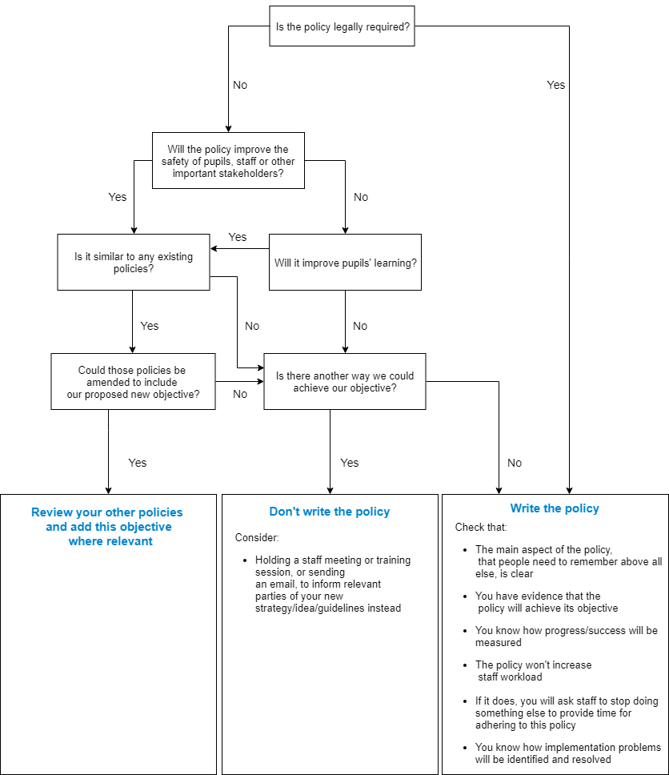
Ensuring staff have capacity to take on a new task is vital to its success and their wellbeing. Our aim is to put the joy back into teaching without compromising pupil outcomes:
Suggested Policy: RSE Policy

- Yes
- Yes
- Yes: Can be integrated with PSHE Ed.
- No
Summing Up & Judgement:
- Best Practice
- Accountability of FGB, staff, pupils & consultation with Parents
- Yes PfA
- Write Policy

“Any Critical Incident
Flow Charts: collate into
Incident Protocols
Folder, in Office”

