95


Inspiring Brighter Futures

Meadowside School

Pupil Personal Presentation Policy
Reviewed: May 2025 Agreed FGB Policies Committee 29.4.25
Date written: | August 2023

Signed by:
Paula Wareing | Head teacher | Date: | 29th April 2025
Josie Tuplin | Chair of governors | Date: | 29th April 2025





Equality Statement
This policy reflects the Equality Act (2010). The basic principle behind the Act is that it is unlawful to discriminate against a person because of their:

- Age
- Disability
- Gender Re-assignment
- Marriage and Civil Partnership
- Pregnancy and Maternity
- Race
- Religion or Belief
- Sex
- Sexual Orientation

This school is committed to the Equality Agenda and we aim to achieve equality of opportunity by challenging and removing direct and indirect discrimination wherever it exists.
We welcome and value the contribution that a diverse community can offer as we aim to:
-Treat all people equally according to needs, irrespective of their race, religion or beliefs, gender re-assignment, sex, age, sexual orientation, physical, mental, sensory or learning disability, marital status, pregnancy and maternity, or economic status, or any other factor
-Not tolerate harassment or intimidation of any kind and will respond to all reports of harassment/intimidation
-Encourage all individuals to apply to us for employment. We value the differences amongst our staff and aim to use their differences in a positive way, towards meeting our vision
-This school is committed to the Equality Agenda and we aim to look after the wellbeing of all our employees, as our duty of care, in achieving an effective work/life balance.
-Promote the school to parents and prospective pupils, welcoming diversity and offering, adaptive teaching approaches in response to the way individuals learn best, personalised support-needs led, to meet the outcomes aspired to in the child/young person’s EHCP and in accumulating cultural capital in preparation for the choices and responsibilities of adult life
-Be committed to ensuring that equality of opportunity underpins all our procedures, policies and work practises, supported with equal opportunities and diversity training for our staff and reinforced across the whole curriculum for our pupils.
-At Meadowside, we will ensure that people with protected characteristics have the same opportunities as those without or have equity of accessible opportunity. We will not treat a pupil/staff member less favourably than others. We will make all reasonable adjustments to ensure that a pupil or member of staff is not placed at a disadvantage because of the nature of their protected characteristic.
-We acknowledge equality of opportunity does not mean everyone has the same, so we enable equity of opportunity to provide fairness by giving students varying, perhaps unequal, but proportionate levels of support to meet their individual needs. Equity recognizes that each pupil has different needs and background experiences, so we allocate the necessary resources and opportunities needed to reach an equal outcome.

Contents:
Statement of Intent
- Legal framework
Implementation
- Roles and responsibilities
- Considerations
Impact
- Reasonable Adjustments/Anti-Discrimination
- Monitoring and review
- Communication with Parents/Carers/Prospective Parents/Carers

Statement of Intent

At Meadowside School, our intent is to be inclusive, to support pupils to wear a uniform, represent the school well, not be discriminated against for hair styles and to grow their resilience and self-esteem. We want them to feel and look like part of a team, reduce opportunities for bullying and peer pressure, and dress appropriately for activities, our curriculum offers. Governors, take this seriously, and wanted to consider the costs, and other considerations, when making decisions.

This policy is to be used to integrate a whole-school ethos towards healthy lifestyles and help both staff and pupils present well, perform well, concentrate better, and improve general wellbeing.

Governors are aware that one of the barriers to attendance can be affordable, comfortable, school uniform. They understand that some pupils with SEND have difficulties related to coordination, physical difficulties and/or sensory processing differences, and uniform can be a considerable issue.

Meadowside School also aims to teach pupils to make smart, personal presentation choices, through the curriculum.

We acknowledge the important connection between a dress code enabling a sense of occasion/community and a pupil’s ability to learn, concentrate, and achieve high standards in school. We are, therefore, committed to promoting a lasting healthy lifestyle for everyone, supporting learners to choose to dress hygienically, appropriate to a role or an occasion, and behave with maturity.

As part of our positive personal presentation code, our staff will uphold the highest standards of presentation, practicality in their dress code and cleanliness; adhering, without exception, to model, dressing for a purpose and empowering learner behaviours and attitudes, in readiness to learn. As such, this policy is to help staff and parents deliver consistent messages to pupils, enabling them to develop a positive and independent approach to lifestyle, choices.

Meadowside School’s uniform can play a key role in:
- Promoting the ethos of the school
Providing a sense of belonging and identity
- Setting an appropriate cue for education
- Safeguarding children and young people
- Health and Safety of pupils
Meadowside school leaders will foster an inclusive environment by ensuring their hair policies, are not unlawfully hair discriminatory. This guidance applies to all forms of hair discrimination, although it focuses on race because of the disproportionate impact upon pupils from specific racial groups.

Legal framework
This policy has due regard to all relevant legislation and statutory guidance including, but not limited to, the following:
- Human Rights Act 1998 and the
- Equalities Act 2010
- Cost of school uniforms.
This policy operates in conjunction with the following non-statutory guidance:
- DfE guidance relating to uniform
- Preventing hair discrimination in schools
This policy operates in conjunction with the following school adopted policies:
- KCSiE
- Health and Safety Policy
- Supporting Pupils with Medical Conditions Policy
- Pupil Equality, Equity, Diversity and Inclusion Policy
- Child Protection and Safeguarding Policy
- Behaviour Policies
- Dignity at work, + addendum Meadowside Staff Dress Code
- Mental Health and Wellbeing (MH&W) Policy, (to be collated)
Meadowside School’s Governing Board decide:
- rules around appearance
- whether there should be a school uniform policy and if so, what that should be
- how the uniform should be sourced,
to ensure that all school policies promote good behaviour and discipline amongst the learning community.

IMPLEMENTATION:

Roles and responsibilities
The governing board are responsible for:
- Ensuring the school promotes healthy personal presentation codes to pupils and Behaviour for Learning policies.
- Ensuring the school meets the requirements of the DfE Guidance relating to Uniform.
- Meadowside Staff Dress Code
The head teacher will be responsible for:
- The overall implementation of this policy.
- Managing, or appointing a member of staff to manage, the school’s approach to implementing an inclusive uniform.
- Putting measures in place to ensure the school meets the requirements of the Human Rights Act and other related legislation, such as the Equalities Act.

Senior Leaders including Governors:
- Consider how comfortable the proposed uniform will be for pupils
- Take a sensible approach to allow for exceptions to be made during extreme weather, eg: allowing pupils to wear shorts in very hot weather or allowing trousers to be worn instead of skirts in very cold weather
- Ensure that their uniform is non-gender specific, suitable and safe for pupils who walk or cycle to school, for instance, by allowing pupils to wear a coat which they could be visible in, when it is dark going home
- Choose a PE kit which is practical, comfortable, appropriate to the activity involved and affordable
- Ensure the final policy is published on the school’s website so it is easy for parents (including parents of prospective pupils) to access and understand
- Consider carefully the risk of a challenge to the policy and consider the appropriate insurance cover

Consider other relevant factors, e.g: the manufacture of items of clothing, that can have a significant impact on the environment, ie: how materials are sourced.
On occasion, uniform requirements may be relaxed temporarily e.g: in support of a special event. These events will be communicated with parents by Class Dojo, telephone or letter, with clear start and end dates.
Post 16 students are not required to wear school uniform and are expected to dress smartly with practicality for curriculum activities, in non-revealing, inoffensive clothing.
Inspiring Brighter Futures

Meadowside School Uniform
and Readiness to Learn.

It is our policy that all pupils from Year 7 to Year 11 wear school uniform when attending school, representing the school, or when participating in a school-organised event. Our aim is that pupils of Meadowside School will develop and feel a sense of community and belonging through the wearing of our school uniform. However, we do have a relaxed approach to uniform as we understand the differing needs of our pupils.

This should consist of: | Optional extras include:
Jade green short-sleeved polo shirt [with or without school logo]  Black or dark grey trousers, skirt or pinafore, &/or long shorts,  Jade green long-sleeved round -neck sweatshirt or cardigan [with or without school logo]  Dark coloured socks/tights  Dark coloured shoes with non-marking soles, chosen for practicality, and to support mobility and independence. | Jade green coloured fleece jacket [with or without school logo]  Jade green/blue school bag [with or without school logo]  Jade green coat [with or without school logo]
Every day pupils should bring: (of own choice) | Pupils should not:
A Water Bottle and Tissues,  When it is hot - a hat\sun screen,  When it is cold or wet - a coat and gloves, (to wear at breaktime or during outdoor learning, even if not required on transport), | Expect to wear hoodies, or keep their coats on indoors,  (If this becomes an issue, items will be confiscated until parents collect)  Wear gingham summer dresses,  Wear flip-flops, sliders, backless shoes,  Wear hobby related shoes such as hiking boots, trainers, wellies or wheeled shoes.  Expect school to take responsibility for, or replace expensive items.
ALL ITEMS TO BE CLEARLY MARKED WITH PUPIL’S NAME
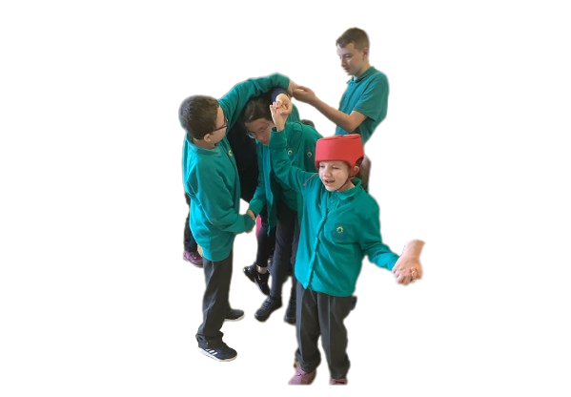
Meadowside School Uniform Photos:
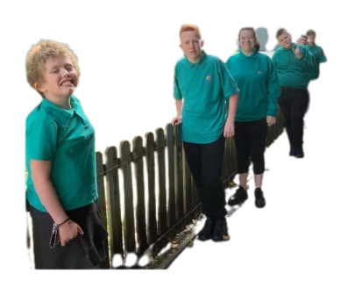
PE kit should consist of: | Swimming kit should consist of:
- Sports shorts and/or sports trousers (dark coloured, where possible)  - Plain white t-shirt  - Trainers with non-marking soles  - Toiletries & Comb | - Swim shorts (for boys) and swimming costume (for girls)  - Large towel - 2 towels for pupils with long hair and for non-ambulant pupils  - Continence wear for those who need it  - Toiletries & Comb
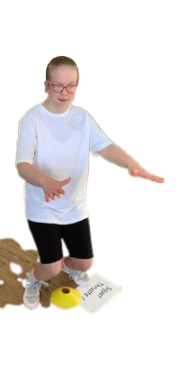
PE and Swimming Kit

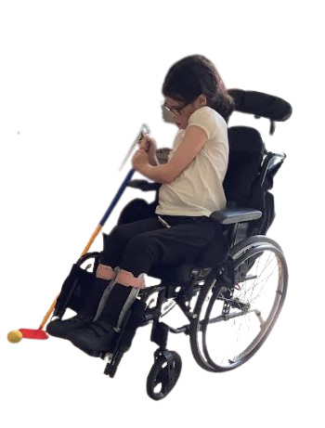

Both brought to school in a bag of the pupils’ own choice.
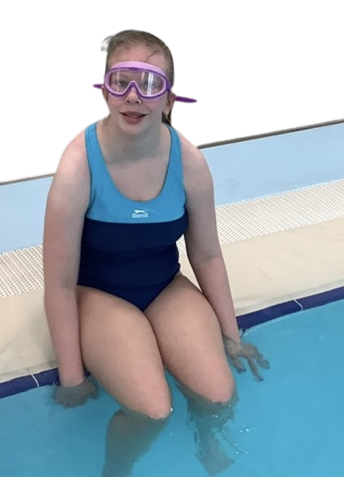
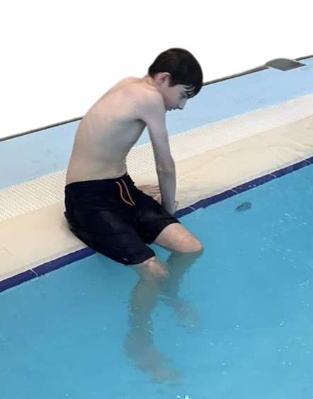
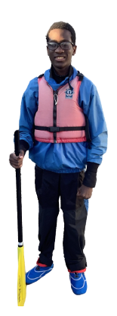
All items, including bag, labelled with pupil’s name
Outdoor/Active Learning Kit
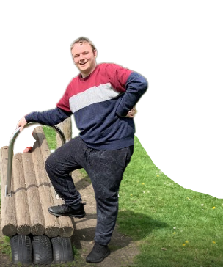
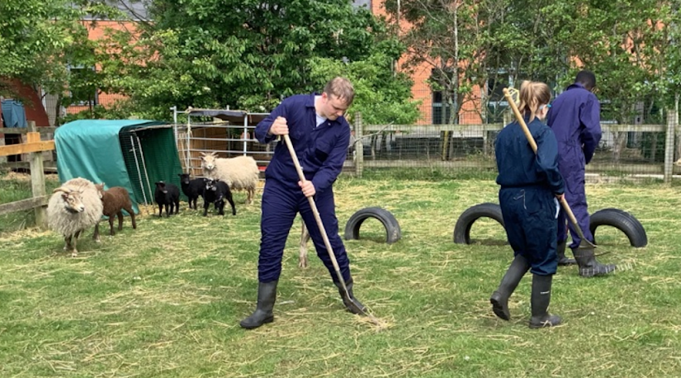
Guidance around this will be issued to those pupils participating in outdoor learning by the teacher in charge of the activity.

Parents will be given sufficient notice if required to source items and are welcome to approach school for advice to support with this.

School has a small number of water proof outfits available.
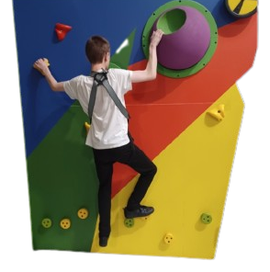

How to Order School Uniform:
Orders can be placed and paid for on-line, at www.myclothing.com following the order instructions. Uniform can also be purchased from The Uniform Shop opposite the old Argos store in Birkenhead or from First Class Uniform and Workwear, on Seaview Road in Wallasey or from any supermarket – Please contact reception for further details or, to check, as we sometimes have recycled uniform, as an option or as samples to gauge sizes.
Post 16

Post 16 students are not required to wear uniform. However, the clothing worn by students must still follow some fundamental principles:
- It must be safe and practical for school use,
- It must not promote unacceptable or offensive messages – drugs, violence, racism, politics, sarcasm, etc.
- The Head Teacher or representative will decide on limits of acceptability.
- It must not conceal identity.
- Caps, hats, hoodies, or any other headwear are inappropriate to wear within the school.
- Smart, casual wear is acceptable, within limitations:
NOT PERMITTED:
Ripped denim, onesies, nightwear, military wear/camouflage, cropped tops, short shorts or other revealing items.
Should a pupil present at school in unsuitable clothing, they will be offered an alternative and expected to wear it. If resolution cannot be reached, parents/carers will be called to bring alternative clothing, or collect the pupil to go home and change.

Prevention of Hair Discrimination

“Pupils will not be stopped from wearing their hair in natural ethnic styles at school,” - Equality and Human Rights Commission (EHRC) guidance. Race is a protected characteristic under the 2010 Equality Act, which means a person must not be discriminated against, because of their hair or hairstyle, if it is associated with their race or ethnicity. This includes natural Afro hairstyles, braids, cornrows, plaits and head coverings, amongst other styles.
Hair must be worn in an appropriate conventional style, that can easily be kept neat and safe, so that pupils can effectively participate in all educational activities.
Not Permitted:
Extreme fashion hairstyles, e.g. shaving or less than No.2 cut, all over.
Punctual presentation of pupils/students who travel to school independently or with family/carers
It is important that students arrive promptly each day. Pupils who are late must register their lateness and sign in, with Reception staff. We require parents to provide an appropriate reason and cannot allow this to become a regular occurrence.
The school celebrates good attendance to motivate others to improve their attendance and recognises this with various events. Please see Attendance Policy, also on our website. For all queries re: Attendance, please contact our Family Support Worker or Deputy HT Pastoral and Community.
Mobile Phones and Devices:
Mobile phones, iPods, headphones and other personal electrical devices are not to be seen in the learning environment or on the school site, other than to present, on the door, to hand over on arrival/collect these at the door on final exit, or if arriving late/leaving early: hand in to/collect from the School Office. Ear defenders may be used.
- On entry to the school building, mobile phones, iPods, headphones, iPads etc. need to be switched off and handed in, on arrival, to be stored in the School Office
- Personal electrical devices will not be allowed to be used in learning environments for research, as a calculator, or for telling the time.
- Smart watches are not to be used on the school’s network.
- All the above and any other personal electronic/digital devices are to be collected on the door/from the School Office, just prior to leaving the site and are not allowed to be switched on/used until pupils have left the site.
We do appreciate that you may prefer your child to have a mobile phone, and this can happen, either side of the school day. In any emergency, during the school day, please contact the School Office and we will support your child.

Make-Up & Nail Varnish:

Pupils in Y7, 8, or 9 are not allowed to wear make-up or nail varnish. Pupils in Y10 and above may wear light, natural looking make-up, eyelashes and nails. Pupils/Students will be asked to remove make-up, if a member of Staff deems it inappropriate.

Jewellery:

For health and safety reasons, NO jewellery is to be worn, except a watch or stud earrings for Y7, 8 & 9. Watches must be removed before PE and Swimming sessions as school will not be held responsible for lost or damaged items.
KS4 & P16 pupils/students may wear minimal, jewellery, such as a plain neck chain and stud earrings, (facial, or other body piercings e.g. navel, lip, are not permitted). Watches must be removed before PE and Swimming sessions.
P16 students may wear minimal, plain jewellery, eg: signet ring and low cost items.

Any items brought into school, in breach of this Policy, after serious consideration for reasonable adjustments, will be held in the School Office for collection just before leaving the site, or, if deemed necessary, to be collected by parents.

PLEASE NOTE THAT EXCEPTIONAL CIRCUMSTANCES/CASES, WILL ALWAYS BE CONSIDERED.


Tattoos and Piercings

Please note: Pupils/students must not get new piercings or small unseen tattoos done at any time that will impact negatively on their full participation in lessons, specifically in swimming or PE.

School staff are unable to support with the care of new piercings or tattoos, and cannot replace the jewellery in any piercings which come out in school.

Equipment:

Young people need to present prepared for their day and curricular activities. They need to bring in named equipment/kit as required, in a named bag.

Every day, all young people must have a READING BOOK/access to SENSORY OBJECTS of REFERENCE to a story, as appropriate, and have their TIMETABLE, to support their independence, self-help skills and communication/literacy skills.

Partnership:

Parents/Carers are seen as vital in maintaining the high standard of uniform, personal presentation and readiness to learn, at our school. If unsure, parents/carers and pupils/students are advised to contact the school to discuss this further.

As Parents/Carers, when you attend your child’s Admissions Meeting at Meadowside School, you will sign a Home/School Agreement. This essentially means that you will support our Codes of Conduct and our expectations. This is in light of our shared understanding that:

PLEASE NOTE THAT ALL EXCEPTIONAL CIRCUMSTANCES/CASES, WILL ALWAYS BE CONSIDERED and REASONABLE ADJUSTMENTS MADE, as required.

IMPACT:
We have prioritised the following considerations, when developing this uniform policy:
- Cost,
- Comfort,
- Equality and Human Rights,
- To be as inclusive as possible, so that all pupils can wear the uniform.
- Sensitive to the needs of different cultures, races and religions and acting reasonably in accommodating these, without compromising, important school policies, eg: school safety or discipline. Most religious requirements will be met within our school uniform policy and our governing board will act reasonably through consultation and dialogue in accommodating these.
- Its obligations not to discriminate unlawfully, eg, whilst school can designate different uniform requirements for boys and girls, girls’ uniforms should not be significantly more expensive than boys’ or vice-versa, as this may constitute unlawful sex discrimination.
- Senior Leaders will engage with parents and pupils to ensure that its uniform policy is suitable for our school community, recognising that our school community may change over time.
- The policy will need to be flexible enough to allow for necessary exceptions, as

reasonable adjustments must be made, as appropriate, for pupils with a disability.
Challenges to school uniform policy
The governing board expect to consult and work closely with parents to arrive at a mutually acceptable outcome. Our school uniform is inclusive, and we expect Senior Leaders to be considerate when implementing the policy so that the uniform can be worn by all pupils. Our governing board will carefully consider requests to vary our uniform policy. School leaders and Teachers will deal with pupil non-compliance in a proportionate and fair way.

Reviewing the policy
Meadowside School will review this policy at appropriate intervals to ensure that it is still fit for purpose or considering any changes to relevant legislation.
The next scheduled review date for this policy is July 2026.

Parents /Carers/Pupils are invited to make comment, which will be taken into consideration. Any changes made to this policy will be communicated to uniform providers, family support worker, parents and other stakeholders, and be on our website.

