44

MEADOWSIDE SCHOOL
Inspiring Brighter Futures

Computing Policy

Date policy last reviewed: | 04.25

Signed by:
Paula Wareing | Head Teacher | Date: | 15th July 2025
Josie Tuplin | Chair of governors | Date: | 15th July 2025

Computing Policy
Reviewed April 2020, November 2020, May 2021, September 2021, March 2023 July 2023 April 25
K Charmley
Rewritten May 2019 Curriculum Committee: 14.5.19
Previous policy written in 2011 and updated every 2 years,
with Governor agreement and ratification as required.
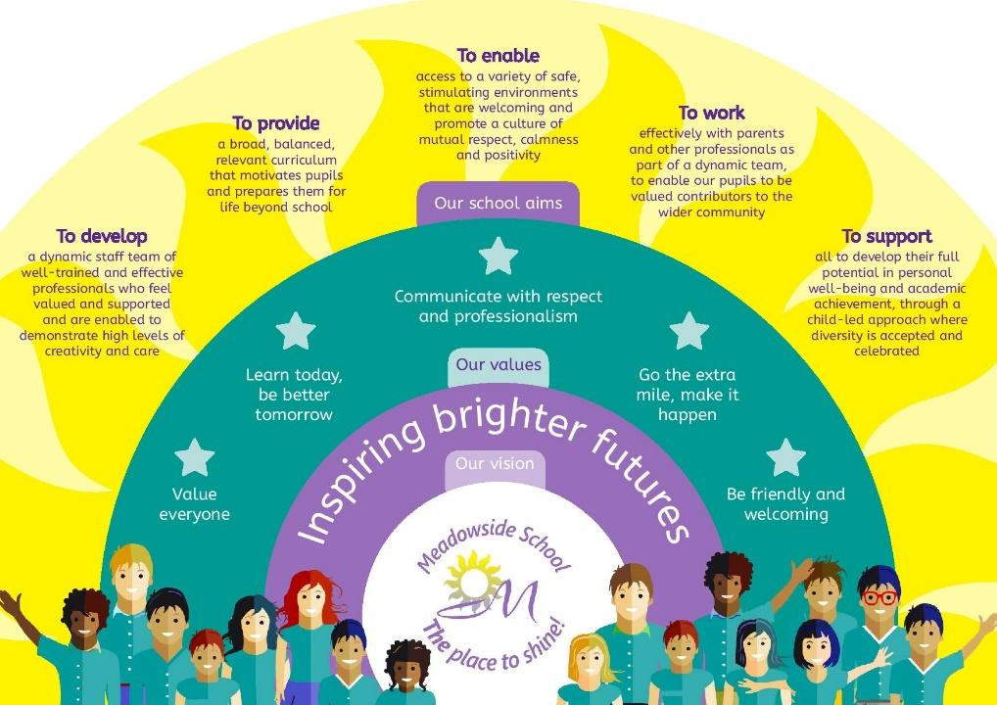


Equality Statement
This policy reflects the Equality Act (2010). The basic principle behind the Act is that it is unlawful to discriminate against a person because of their:
- Age
- Disability
- Gender Re-assignment
- Marriage and Civil Partnership
- Pregnancy and Maternity
- Race
- Religion or Belief
- Sex
- Sexual Orientation

This school is committed to the Equality Agenda and we aim to achieve equality of opportunity by challenging and removing direct and indirect discrimination wherever it exists.

We welcome and value the contribution that a diverse community can offer as we aim to:

Treat all people equally according to needs, irrespective of their race, religion or beliefs, gender re-assignment, sex, age, sexual orientation, physical, mental, sensory or learning disability, marital status, pregnancy and maternity, or economic status, or any other factor

Not tolerate harassment or intimidation of any kind and will respond to all reports of harassment/intimidation

Encourage all individuals to apply to us for employment. We value the differences amongst our staff and aim to use their differences in a positive way, towards meeting our vision

This school is committed to the Equality Agenda and we aim to look after the wellbeing of all our employees, as our duty of care, in achieving an effective work/life balance.

Promote the school to parents and prospective pupils, welcoming diversity and offering, adaptive teaching approaches in response to the way individuals learn best, personalised support-needs led, to meet the outcomes aspired to in the child/young person’s EHCP and in accumulating cultural capital in preparation for the choices and responsibilities of adult life

Be committed to ensuring that equality of opportunity underpins all our procedures, policies and work practises, supported with equal opportunities and diversity training for our staff and reinforced across the whole curriculum for our pupils.

At Meadowside, we will ensure that people with protected characteristics have the same opportunities as those without or have equity of accessible opportunity. We will not treat a pupil/staff member less favourably than others. We will make all reasonable adjustments to ensure that a pupil or member of staff is not placed at a disadvantage because of the nature of their protected characteristic.

We acknowledge equality of opportunity does not mean everyone has the same, so we enable equity of opportunity to provide fairness by giving students varying, perhaps unequal, but proportionate levels of support to meet their individual needs. Equity recognizes that each pupil has different needs and background experiences, so we allocate the necessary resources and opportunities needed to reach an equal outcome.

Contents:
Statement of intent
- [Updated] Legal framework
Implementation
- Roles and responsibilities
- Overall curriculum aims
- The curriculum
- Teaching
- [Updated] Online learning and safeguarding
IMPACT
- Health and safety
- Monitoring and review

Statement of intent
Meadowside School understands that computing and ICT are an integral part of the national curriculum and that computing skills are important beyond the classroom.
Computers are a valuable resource in school, benefitting the way pupils learn and helping teachers maximise their role as educators. Considering this, our school is committed to ensuring that both staff and pupils have access to the necessary facilities to allow them to enhance their learning experience. We believe that it is important for pupils and employees to be confident and competent users of computers, and other technological resources, to aid development across the curriculum.

“A high-quality computing education equips pupils to use computational thinking and creativity to understand and change the world. Computing has deep links with mathematics, science, and design and technology, and provides insights into both natural and artificial systems. The core of computing is computer science, in which pupils are taught the principles of information and computation, how digital systems work, and how to put this knowledge to use, through programming. Building on this knowledge and understanding, pupils are equipped to use information technology to create programs, systems and a range of content. Computing also ensures that pupils become digitally literate – able to use, and express themselves and develop their ideas through, information and communication technology – at a level suitable for the future workplace and as active participants in a digital world.”
“DfE National Curriculum September 2013”
The intent of this policy is to set out how Computing is led, coordinated and delivered at Meadowside School, ensuring that safe practice in the use of technology and the online world is an ongoing part of this, in accordance with ‘Keeping Children Safe in Education’.

Legal framework
This policy has due regard to all relevant legislation and statutory guidance including, but not limited to, the following:
- DfE ‘Keeping children safe in education’
- Data Protection Act 2018
- UK General Data Protection Regulation (UK GDPR)
- Equality Act 2010
- DfE (2013) ‘Computing programmes of study: key stages 1 and 2’
- DfE (2013) ‘Computing programmes of study: key stages 3 and 4’
This policy operates in conjunction with the following school policies:
- Digital Safeguarding Policy
- Business Recovery Plan
- Data Protection Policy
- Technology Acceptable Use Agreement for Pupils
- Technology Acceptable Use Agreement for Staff
- Pupil Equality, Equity, Diversity and Inclusion Policy
- Teaching, Learning & Assessment Policy
- Marking & Feedback Policy
Implementation

Roles and responsibilities
The governing board will be responsible for:
- Monitoring the effectiveness of the Computing curriculum.
- Monitoring the progress of pupils in Computing.
- Holding the head teacher and Computing subject leader to account for pupils’ Computing progress, and the implementation of the Computing curriculum.
- Ensuring the school has appropriate filtering and monitoring systems in place on its Computing system to safeguard pupils.
Overall responsibility for monitoring the teaching of Computing throughout the school will lie with the ICT Strategic Lead, who will make decisions on:
- Monitoring and evaluating the effectiveness of the provision of the Computing curriculum.
- How Computing should support, enrich and extend the curriculum.
- The provision and allocation of resources.
- The ways in which the need for developments in the school’s Computing system can be assessed and records can be kept for these developments.
- How Computing can benefit the aims and objectives of the whole school.
The Computing subject leader and head teacher will be responsible for overseeing the implementation and reviewing of this policy.

The Computing subject leader will be responsible for:
- To plan, deliver and assess the Meadowside Curriculum for Computing.
- To provide an enriching Computing curriculum for all learners through adaptive teaching, effective feedback, quality software, hardware and effective internet use.
- To be aware of exceptional talent and to encourage and stimulate this talent.
- To ensure access to the Computing curriculum for pupils with SEND eg. Adaptive teaching, equipment and software.
- To attend courses and meetings, to keep up to date with developments and issues.
- To promote extra-curricular activities as an extension to classwork.
- To support and monitor Computing teaching through other subjects.
- Overall responsibility for monitoring and development of Computing within the curriculum will lie with the DHT Curriculum & Assessment and the Computing Subject Leader. However, as Computing is a statutory part of all subjects within the National Curriculum it is:
- Coaching individual Subject Leaders to be looking for ways of developing Computing within their areas and sharing information with other colleagues.
- The methods and procedures for assessing, recording and reporting the progress within Computing are consistent with the school’s Assessments,
- Monitoring the progression of teaching and learning in Computing.
- Managing resources and advising staff on the use of materials.
- Supporting teaching staff to deliver the Computing curriculum and monitoring the quality of teaching and learning.
- Keeping abreast of technological developments and using these to inform practice.
- Leading staff training on new Computing initiatives.
Teachers will be responsible for implementing this Policy:
- Planning lessons & adapting teaching, in response to how individuals learn best,
- Providing equality of opportunity to all pupils through their teaching approaches and methods.
- Keeping up-to-date assessment records.
- Ensuring pupils’ development of skills and knowledge progresses through their learning and understanding of Computing.
- Setting pupils appropriate targets based on their needs and prior attainment.
- Maintaining an enthusiastic approach to Computing.
- Taking part in Computing training and other CPD opportunities.
The Computing technician will be responsible for:
- Maintaining and keeping Computing equipment in good working order.
- Dealing with any reports of broken, damaged or faulty equipment.
- Ensuring the school’s Cyber Response and Business Recovery Plan is adhered to.
- Carrying out checks on all computers once per term.
- Adjusting access rights and security privileges in the interest of the school’s data, information, network and computers.
- Monitoring the computer logs on the school’s network and reporting inappropriate use to the head teacher.
- Disabling the user accounts of staff and pupils who do not follow school policies, at the request of the head teacher.
- Assisting staff with authorised use of computing facilities, if required.
- Assisting the head teacher in all matters requiring reconfiguration of security and access rights, and all matters relating to this policy.
- Accessing files and data to solve problems for a user, with their authorisation – if an investigation is required by the head teacher, authorisation from the user is not required.
Pupils will be responsible for:
- Using the school’s computing facilities appropriately.
- Being aware of the school’s rules around the use of computing equipment during lessons.
- Understanding how the use of computing improves learning.
Parents will be responsible for:
- encouraging computing skills and safe computing use at home.

Overall curriculum aims

For pupils to learn to:
- Evaluate and apply information technology, including new or unfamiliar technologies, analytically to solve problems.
- Be responsible, competent, confident and creative users of information and communication/control technology.
Curriculum Aims | Expected Outcomes
- Learners will enjoy and make significant achievements, that will develop their computing and COMPUTING literacy for everyday life. | - Learners will be happy and well behaved in Computing lessons.  - Learners will achieve some degree of success in every lesson  - Learners will want to make progress in their computing.
- Through the Computing curriculum, learners will also develop their logical thinking skills along with creative thinking and evaluative skills. | - Learners will access the four aspects of the Computing curriculum  - Digital Literacy  - Digital Citizenship  - Digital Creativity  - Computing  - There is Accreditation using the AQA UAS for learners in Key Stage 4 and Post 16.
- Computing will develop learners’ skills in working both independently and with each other promoting communication skills | - Learners work individually, in pairs and in small and whole class groups on tasks tailored to enable them to make progress.
- Computing will make a positive contribution to the school and community as well as to learners self-esteem and confidence. | - Learners will use computing for real purposes such as school notices for forthcoming events/ rules/ class phone numbers etc.  Learners will develop computing projects on ideas that they are personally interested in, taking a role in planning their own learning outcomes.
- Learners will stay safe when undertaking Computing activities. | - Equipment will be monitored and maintained regularly.  - Extra- curricular activities will be regulated by the school’s procedure for Risk Assessments.  - Learners follow the school’s Digital Safeguarding Policy for keeping safe and learn the importance of ESafety for inside and out of school.

4. Computing Curriculum and Adaptive Teaching
For those following the Formal curriculum, Computing lessons are taught discretely by the Subject Leader, once a week. The Leader’s Long-Term Plan outlines the knowledge and skills to be taught, in sequence, linking each to Digital Literacy, Digital Citizenship, Digital Creativity and Computing. This is on a 3 year, KS3 carousel, to ensure a range of coverage building on prior learning as pupils progress though the Key Stages. At Key Stage 4 and Post-16 pupils may gain accreditation using the AQA Unit Award Scheme.

The semi-formal curriculum and pre-formal assessments, incorporate the use of technology within the ‘My Communication’ domain. For some pupils, technology is used to aid communication on a day-to-day basis.
In pre-formal, the teaching of ‘cause & effect’, as a basic concept helps pupils grasp and understand their agency in everyday life and encourages exploration and interaction. Once this is retained learning, pupils learn to recall, and recognise that a movement, action or something they do, can be rewarding, as it makes something else happen. This offers pupils some control over their world, as they learn what they can do for themselves, and what they can influence others to do, for them!
Home Learning: Knowledge Organisers
Every term, each year group will be informed on the website, of what is expected of them with regards to Computing and the term’s key vocabulary to be learned.
Parents will receive a termly magazine informing them about the main aspects and units of work that have been covered.
Adaptive Teaching, Personalised Support
The teaching of Computing will ensure that pupils on all pathways are able to engage with the curriculum as effectively as possible, enhancing their knowledge and skills.
The skills needed for pupils to access the wider curriculum using technologies will be mapped and developed to ensure that pupils can use computing applications progressively through the curriculum.
Teachers will use technology to allow pupils to investigate, solve problems, refine their work, learn from their mistakes and reflect critically.
There will be a good balance across the whole school between the high-quality use of technology and computing to support and enhance teaching and learning, and the individual pupil’s productive use of technology to support their own learning, including personalised support.
Teachers will be sensitive to the fact that some pupils may not have access to a computer at home.
On-line opportunities will be used to support and extend learning beyond the school, through activities integrated with pupils’ school-based learning.
5. Online Learning and Safeguarding
The school recognises the importance of teaching pupils about online safety, the potential dangers of the internet and their responsibilities when using communication technology – as set out in the school’s Digital Safeguarding Policy.
As part of the school's commitment to the principles outlined in the most recent version of KCSIE, the school will:
- Offer a safe online environment through filtered and monitored internet access.
- Ensure the filtering systems in place will prevent pupils from accessing terrorist and extremist materials, in accordance with the school’s Digital Safeguarding Policy and the Prevent duty.
- Take care to ensure the use of filtering and monitoring does not cause “over blocking”, which may lead to unreasonable restrictions on what pupils can be taught.
- Run assemblies on a termly basis about the potential dangers of the internet and how to stay safe online.
- Teach pupils about internet safety and cyberbullying during PSHE Ed lessons.
Pupils and staff who use the school’s ICT facilities inappropriately will be reported to the head teacher, and the DSL where appropriate.
The governing board will ensure the school has appropriate filtering and monitoring systems in place for Computing lessons and regularly review their effectiveness. The SLT and other relevant staff will have an awareness and understanding of the provisions in place and manage them effectively and know how to escalate concerns when identified.
The ICT technician will keep internet filters and other safeguarding controls up-to-date and routinely check their effectiveness to avoid misuse and protect pupils.
Online learning is increasing year by year; more recently we have seen a substantial increase in online learning during and following the COVID 19 outbreak, which in some cases has been embraced and led to more permanent changes.
“As schools and colleges increasingly work online, it is essential that children are safeguarded from potentially harmful and inappropriate online material. As such, governing bodies and proprietors must ensure appropriate filters and appropriate monitoring systems are in place.” KCSIE
- Meadowside benefits from access to digital content. Each classroom is connected wirelessly to the Internet, allowing varying access around the school, using devices such as PCs, laptops and
tablets.
- The internet and other digital information technologies are powerful tools, opening new possibilities for finding information, communicating and collaborating.
- Meadowside has a filtering system in place (via MGL), an acceptable-use policy that teachers, pupils, (as appropriate), and parents sign up to, including on-line supervision and a firewall (via MGL). Rules governing access to the Internet and E-mail communication are set out in the School’s Digital Safeguarding Policy.
- Access to the internet at home, however, may not be mediated by such safety mechanisms. There is no fail-safe technological solution that will protect children from all the risks they may encounter online. Pupils are therefore taught safe behaviours that they should adopt whenever they are using the internet.
- These are refreshed each year through computing lessons focusing on Digital safety. We generally link these lessons in with the annual Safer Internet Day, run by Safer Internet Centre.
- The Subject Leader maintains an electronic and password protected log of Digital Safety issues, noting action taken each time. Digital on-line access via iPads are subject to daily monitoring, identifying unsafe activity or settings.
- No learner at Meadowside will have access to the Internet without a vigilant member of school staff being present in the classroom and aware of planned on-line activity. This is important if we are to maintain allowing our pupils to access platforms such as You Tube within school. Pupils are aware that they must ask before accessing YouTube. This is documented on a poster in each classroom, as a reminder for pupils.
6. Resources
All classrooms have Interactive Whiteboards, all of which are non-projected, ensuring a high-quality image, not blocked out by the user’s shadow. Some also benefit from being height adjustable and have wireless controllers enabling staff to lead from within the group.
- All teaching rooms have at least one PC. Teaching staff have a laptop. This enables computing to be incorporated, as relevant into teaching across the school. Pupils can access computing during lessons by use of mini laptops and ipads, as available. iPads and portable laptops have enabled Computing to become a more mobile solution, although some lessons are taught in a single classroom, set up to maximise access to the equipment.
- Computing is a constant aspect of the School Development Plan. The emphasis of development reflects national and local initiatives and the changing needs of the learners.
- Computing Training is identified as part of a Strategic Computing Development Plan. Computing training is available to all staff within the school. The personal development of Computing skills is actively encouraged, and a range of formal and informal sessions take place after school hours or during INSET sessions. There is now also a weekly drop-in session available for staff to attend as training requirements/needs arise. The Computing equipment is available for use by school staff from 3.15 each evening.

Technical Support
Technical support is provided on two levels. Basic troubleshooting and problem solving is currently provided by the Computing Subject Leader Kath Charmley. More involved problems are solved via the MGL, with a weekly visit by a technician. We also have access to emailing the MGL Helpdesk for any small issues/jobs that can be solved remotely.
MGL provide our filtering system (Smoothwall) for all devices, and a centrally controlled management system for the iPads (Jamf) to ensure consistency, regular updates and monitoring of staff and pupil iPads.
Resources for Computing are devolved through the school budget allocation, some from Capital Formula and from any National Initiatives funding.
- The rational for spending resources is outlined annually through the subject development plan.
- Requisition is requested through the school process and reviewed annually.
- Development time to familiarise staff with new resources is allocated through INSET and/or staff meetings.
- Assessment for individuals, and the subsequent purchase of specific equipment identified is sometimes funded through the Local Authority, school fund or the Home School Association.
- Access devices such as switches and a selection of keyboards are available in the Computing cupboard/Yellow Room and with the Subject Leader. These are for the use of any learner in any subject.
- Via the Scheme of Work, the school ensures fair access to Computing equipment for all, along with the appropriate use of the Internet.
- Home /School links are developed formally and informally. Parents will often enquire about the suitability of hardware and software at Parents’ Consultation evenings.
- The school website is hosted by E4Education and monitored by the Subject and Curriculum Leads. It is available at www.meadowsideschool.com. Staff are supported to add content themselves, and learners are encouraged to access online resources via school web pages.

Impact

7. Health and Safety
- The practices associated with the use of Computing in school reflect the most up to date Health and Safety Policy. Risk assessments for all items of hardware and peripherals are completed. Individual risk assessments involving learners are carried out as and when required.
- Routine maintenance and the establishment of safe practice procedures for all equipment form part of the Computing health and safety implementation.
- All computers and peripheral devices are secure on computer trolleys, benches or tables, with leads and wiring placed towards walls, cupboards and tied away, so they are not exposed or trailing – except iPads.
- Specific considerations and procedures will be outlined in individual risk assessments.
- All pieces of equipment have an annual electrical safety check through the LA SLA procedures and are recognised by a green sticker (PAT test).
- School Internet policy for safe use by learners.
- The suitability of all ICT equipment and programs will be assessed and updated, if necessary, by the ICT technician to ensure they are sufficient for effective learning.
- Staff will be provided with high-quality induction on safer working practices and training regarding both curriculum delivery and the safeguarding issues around digital safety.
- Any breach of this policy will be reported to the head teacher.
- Use of the school’s internet connection and network use will be recorded and monitored by the ICT technician.
- The ICT technician can remotely view or interact with any computers on the school’s network. The ICT technician will use this to help implement this policy and to identify and solve any problems.
8. Monitoring and Review
The effectiveness of this Computing policy will be evaluated by the following methods:
- Review and use of Strategic ICT and Computing development plans.
- Review of other subject policies to reflect the planning for and use of Computing
- Collation of evidence to show the use of Computing across a variety of subjects.
- Monitoring schemes of work and their effectiveness.
- Identification of staff development needs through school self-evaluation and appraisal.
- Evaluation of effectiveness of Staff Development, from impact.
- Tracking of learner progress and outcomes.
- Reporting to external stakeholders, Governors.

Evidence of pupil progress in Computing takes the form of annotated photographs, printouts and tasks within work books & Pupil Progress Files. Photographic evidence is also collated in the Evidence for Learning app. This is annotated by teacher professional judgement. Data is collected for summative assessment purposes through the Meadowside assessment framework in Evidence for Learning. This is monitored termly, with Assessment data being entered through the EFL app and Expected Outcomes being set for the forthcoming term.
Each half term, a spreadsheet is completed to identify pupils progress as, target: Met, Not Met, or Unable to Assess. Head Teacher and Subject Leader will monitor the provision through monitoring of planning, Annual Reviews and observation of lessons and activities.
This policy will be reviewed annually by the ICT subject leader and head teacher.
Any changes made to this policy will be communicated to all members of staff.
All members of staff directly involved with the teaching of Computing will be required to familiarise themselves with this policy.
The next scheduled review date for this policy is April 2026.

 MEADOWSIDE SCHOOL WORKLOAD IMPACT ASSESSMENT:
Inspiring Brighter Futures
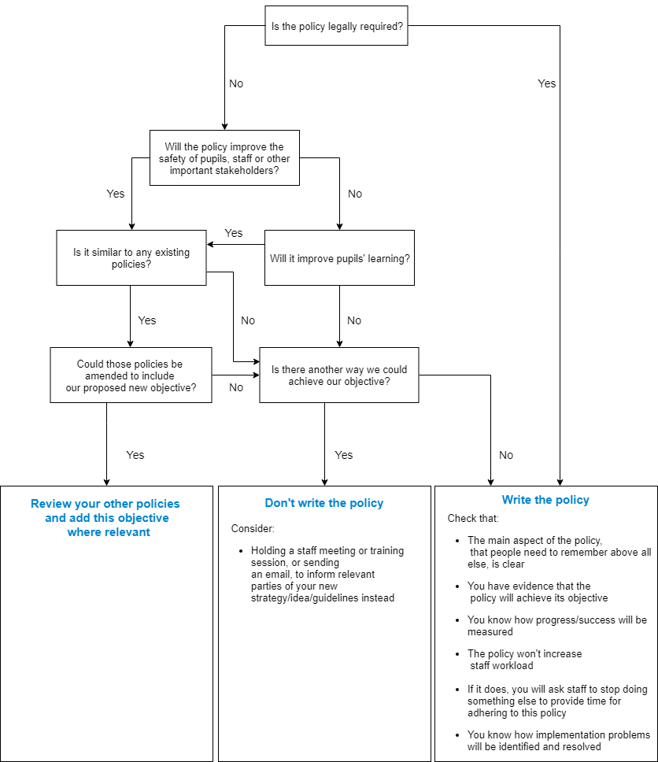
Implementing new proposals or initiatives: Ensuring staff have capacity to take on a new task is vital to its success & their wellbeing. Our aim is to put the joy back into teaching without compromising pupil outcomes:
Suggested Policy: Computing

Summing Up & Judgement:
1. Yes, Best Practice
- Yes 2. H&S of staff, pupils & visitors
- Yes 3. Yes PfA
- No 4. Write Policy
- Write Policy

“ALL Critical Incident Flow Charts: collate into Critical Incident Protocols Folder, in Office”

