Meadowside School
Behaviour Policy
Discipline- from the word ‘disciple’, meaning to guide with knowledge.
Written: February 2020

Author: Claire Dunn


Signed by:
PW | Head Teacher | Date: | 14.1.25
JT | Chair of Governors | Date: | 14.1.25
Review date:  Updated October 2023  Updated September 2025 | Reviewed by: Claire Dunn

Contents

Meadowside School Vision, Values & Aims 4
Equality Statement 5
Statement of Intent 6
1. Legal Framework 7
Implementation 7
2. Roles and responsibilities 7
Impact 13
3. Assessment and Reporting 13
4. Resources 13
5. Equal opportunities 13
6. Monitoring and Review 14
Appendices 15
MEADOWSIDE SCHOOL WORKLOAD IMPACT ASSESSMENT 16

Meadowside School Vision, Values & Aims

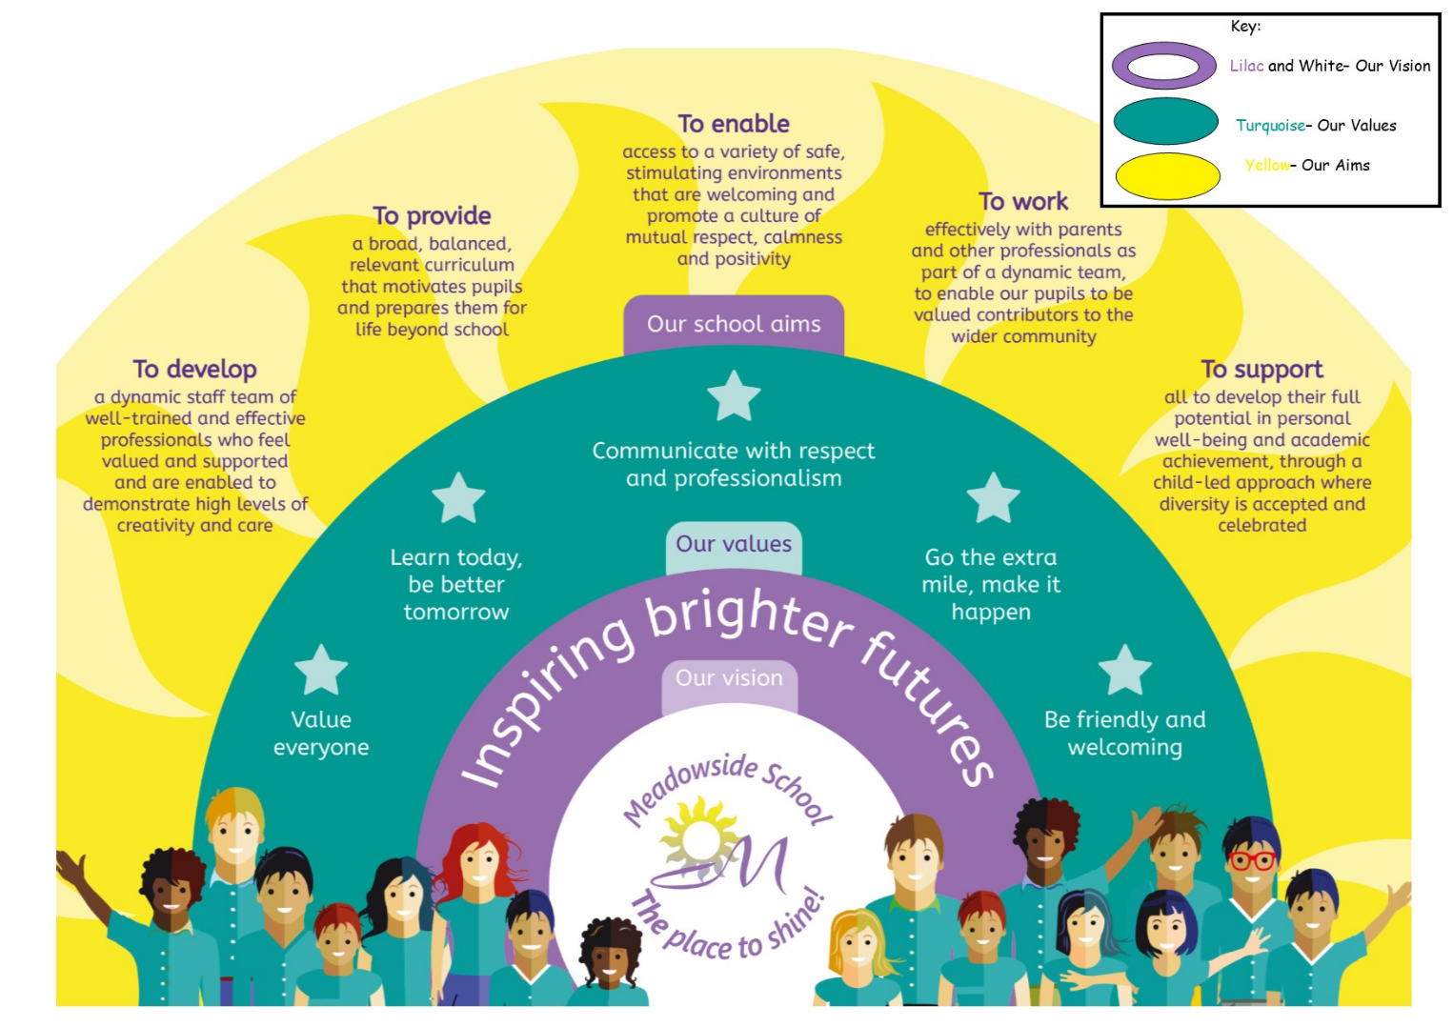

Equality Statement
This policy reflects the Equality Act (2010). The basic principle behind the Act is that it is unlawful to discriminate against a person because of his/her/their:
- Disability
- Age
- Gender
- Race
- Sexual Orientation
- Religion or Belief
- Pregnancy or new motherhood
- Marriage/civil partnership
- Trans-sexuality

This school is committed to the Equality Agenda. We aim to achieve equality of opportunity by challenging and removing direct and indirect discrimination wherever it exists.
We welcome and value the contribution that a diverse community can offer as we aim to:

Treat all people equally according to needs, irrespective of their race, colour, ethnic origin, religion or beliefs, gender, transgender, age, sexual orientation, physical, mental, sensory or learning disability, marital status or economic status or any other factor
Not tolerate harassment or intimidation of any kind and will respond to all reports of harassment/intimidation
Encourage all individuals to apply to us for employment. We value the differences amongst our staff and aim to use their differences in a positive way, towards meeting our vision
Promote the school to parents and prospective pupils, welcoming diversity and offering personalised approaches, needs led, to meet the outcomes aspired to in the child/young person’s EHCP and in accumulating cultural capital in preparation for the choices of adult life
Be committed to ensuring that equality of opportunity underpins all our procedures, policies and work practises, supported with equal opportunities and diversity training for our staff and reinforced across the whole curriculum for our pupils.
If barriers can be overcome, we offer equal opportunities for all, if not then we offer equity of opportunity.
We use a 'total communication' approach to ensure that all pupils can access the lessons – this includes the use of signing, symbols and objects of reference where needed.
All staff have high expectations of all pupils and aim to provide a fully inclusive environment where all pupils can achieve their best.

At Meadowside, we will ensure that people with protected characteristics have the same opportunities as those without. We will not treat a pupil/staff member less favourably than others. We will make all reasonable adjustments to ensure that a pupil or member of staff is not placed at a disadvantage because of the nature of their protected characteristic.

Statement of Intent
Meadowside School prepares pupils to achieve a fulfilling adult life, where they are able to access as many relevant opportunities as possible. In order to do this, they need to be as self-sufficient as possible when it comes to managing their own behaviour. Teaching pupils to self-manage is an integral part of the curriculum which promotes appropriate and relevant social skills to all pupils, allowing them to participate as fully as they are able, in the school, at home and in society.
Supporting behaviour is most effectively done with empathy, consistency, high expectation and in line with the law. This policy outlines these expectations.

This policy will be reviewed in response to any changes to Government and DfE guidance on the ongoing response to Covid-19.

Principles
At Meadowside School it is recognised that there is no single strategy or technique for managing behaviour that meets all pupils’ needs, and a strong and consistent approach, which balances ‘blanket expectations’ with bespoke approaches, is essential, using a risk-benefit, impact assessment strategy.
Appropriate behaviour is vital in the school setting, in order to ensure that learning opportunities are maximised and everybody feels and is safe. This policy supports an ethos where:
- Pupils are encouraged to take responsibility for their behaviour and become effective self-managers.
- Sensory strategies are prioritised and embedded.
- Adverse Childhood Experiences (ACE’s) are considered and responded to appropriately.
- Staff are effectively trained.
- Staff support pupils by establishing appropriate relationships, promoting conventional or augmentative communication, consistently applying strategies and maintaining high expectations.
- Emphasis is placed on recognising appropriate behaviour.
- Pupils are encouraged to develop high self-esteem and self-discipline.
- The whole school community, including therapists, families and other agencies work to support the child holistically.
- Safeguarding is prioritised.
- Pupils feel empowered to speak out against behaviour they encounter, that falls below an expected standard.

Legal Framework

This policy has due regard to all relevant legislation and guidance including, but not limited to, the following:
- Keeping Children Safe in Education, DfE, 2023, with 2025 updates
- Preventing and Tackling Bullying, DfE, 2017
- Use of Reasonable Force in Schools, DfE, 2013
- Suspension and permanent exclusion from maintained schools, academies and pupil referral units in England, including pupil movement. DfE, 2023, including 2024 updates
- Prevent duty guidance: for England and Wales, DfE, 2015 (incl. 2023 updates)
- Use of Reasonable Force, DfE, July 2013
- Use of Reasonable Force and Other Restrictive Interventions in Schools, DfE, 2025

This policy operates in conjunction with the following school policies:
- Anti-Bullying
- Attendance
- Safeguarding
- Suspension

Implementation

Roles and responsibilities

The governing board will be responsible for:
- Monitoring
- Decision making regarding exclusions.

The head teacher will be responsible for:
- The overall implementation of this policy.

The Behaviour Lead, will be responsible for:
- Updating the policy
- Monitoring of incidents, paperwork and recording systems
- Behaviour training and support (other than Team Teach)

Teachers/Lesson Leaders will be responsible for:
- Acting in accordance with this policy.
- Monitoring the behaviour of the pupils they teach
- Carrying out Challenging Behaviour Assessments (CBA’s), writing Personal Support Plans (PSP’s), Help Me Sheets (HMS’s) and Safet Management Plans (SMP’s) for the young people in their pastoral classes.

Although there is a consistently high standard of behaviour required from all pupils, it is acknowledged that not all pupils are able to achieve this standard as readily as others, and therefore require a range of supportive strategies to help them to do so, which are tailor made to meet their individual need.
At Meadowside School we recognise that behaviour is a form of communication, and always seek to equip pupils with words, or augmentative communication that they can use instead of behaviour that challenges, to make their points heard.
Supporting pupils to behave appropriately must be done in a consistent manner. To ensure that this is possible, pastoral teachers write, in the first instance, Help Me/Supporting Strategy Sheets, and then, if further support is required (as identified through careful data analysis and a Challenging Behaviour Assessment), a Personal Support Plan (PSP). These are kept up to date and shared with relevant people. The documents are written following consultation with the pastoral team, or other members of school staff, and the pupil where appropriate, before being agreed with parents (a signed copy of the plan is be kept in the office on the child’s file, an electronic copy is uploaded onto School Pod). They are based on careful analysis of behaviour slips which are logged on the web-based system School Pod. The pastoral tutor analyses the data and decides which behaviour needs to be targeted as a priority. There is no prescription for which behaviours are prioritised, but pastoral teachers consider duration, impact, severity and frequency of behaviours, before making their decision. It is most effective to address the most challenging behaviours as a priority, rather than to overwhelm the child with trying to deal with all of them at once. Behaviour support documentation is reviewed on a termly basis, or whenever there is a significant change in behaviour, whichever is sooner.
In order to build a sound evidence base, it is vital that staff log all behavioural incidents relating to an individual child. In the main, this should be on School Pod. Where there are a lot of incidents, or behaviour is relatively minor, yet concerning, pastoral teachers can use a paper based logging sheet to collect information, for a maximum period of one week. Once a PSP has been written and a ‘baseline behaviour’ has been established, recording of an individual’s behavioural incidents can be personalised. In line with the law, ALL incidents which include restrictive physical intervention (RPI), must be logged on School Pod, which is our ‘bound book’, regardless of whether or not they are also logged on a paper based system. Incidents must be logged as soon as possible, and always within 24 hours.

Meadowside School recognises that proactive approaches are the most effective way to support and promote appropriate behaviour. All members of staff model the desired behaviour at all times. Following consultation with staff and pupils in November 2019, the Meadowside School rules are:
Be here
Behave
Be ready to learn
Be the best you can be (added after consultation with Student Council, Summer 23)
Those consulted felt that the new rules were The rules are memorable, and cover all aspects of positive behaviour, including the school’s Anti-Bullying message.
In order To support pupils to follow the school rules, a calm atmosphere, which is conducive to engagement and learning is required. To ensure that this is possible all classrooms:
- Are as organised and as tidy as possible
- Visual, and other clutter is kept to a minimum
- Have visual schedules and symbols to support communication and understanding
- Have a range of sensory kit available for pupils to access readily.
Lessons are:
- Engaging and use resources which appeal to individual interests and learning styles
- Well planned and organised
- Accurately pitched, and challenging in a ‘low threat’ manner.
- Places where active listening and turn taking are taught and promoted.

The school adopts an individual approach to positive reinforcement. The varying needs of the pupils necessitates a reward system that will celebrate and incentivise their positive behaviour. Staff will choose the rewards they consider most appropriate for individual pupils, and are invited to be creative, rewarding pupils in ways which are most appropriate to their learning environment, without compromising any planned strategies. Acceptable rewards include the following:
- Verbal praise
- Dojo’s.
- Choice of favourite activity
- Tangible reward e.g. Stickers, stars, special job.
- Going to someone else for praise e.g. Head Teacher.
- Special mentions, certificates or stickers to be awarded in assembly
- Notes, phone calls or other communication with home, which is especially important where pupils have communication difficulties.
- Special treats/outings/events
- Short periods of ‘free choice’, which also act as opportunities to self-regulate and process learning.
Food is a basic need and entitlement and therefore should not be used as a reward. However, food is made available to all hungry children, especially where hunger is identified as a behavioural trigger. Certain foods can also be made available as part of a sensory support strategy.

It is acknowledged that de-escalating behavioural incidents is not always straightforward, but it is the primary focus of staff to preserve the safety, dignity, wellbeing and learning of all pupils. It is occasionally necessary to support a pupil in crisis by using restrictive physical intervention (RPI). RPI and restraint are used as a last resort, and for the shortest, most infrequent way possible. All permanent, employed school staff are trained in Team Teach, which uses a 95% de-escalation, 5% physical intervention approach. Team Teach trains staff to use physical intervention safely, and only once all methods of de-escalation have been exhausted. We acknowledge that sometimes our pupils require staff to ‘go the extra mile’, so when it comes to de-escalation, if dancing will help, we dance! Training is refreshed regularly, in accordance with the recommendations of the provider, and staff who are not physically able to carry out the 5% physical intervention, are still required to carry out the 95% de-escalation. The use of RPI, including restraint must only be used as is reasonable, proportionate and necessary. Meadowside School is compliant with the DfE guidance on the use of reasonable force. Use of Reasonable Force, DfE, July 2013

Occasions when it is reasonable, proportionate and necessary to use RPI, including restraint:
- To separate a fight between pupils (when a verbal warning has been given but not responded to)
- To keep a pupil or pupils safe
- To prevent significant damage to property
- To keep staff or visitors safe
- To preserve the learning environment
- To remove a pupil from the classroom where direction to do so has not been followed
- When searching a non-compliant pupil for the following items:

- knives and weapons
- alcohol
- illegal drugs
- stolen items
- tobacco and cigarette papers
- fireworks
- pornographic images
- any article that has been or is likely to be used to commit an offence, cause personal injury or damage to property
Restraint cannot be used to search for items banned under the school rules e.g. mobile phones. However, it is possible to remove a pupil from the vicinity of others if they are believed to be concealing items which may cause harm to others. In this case the pupil would be given repeated opportunities to hand over the offending items and a parent would be called to come and collect the items before the child is able to return to class.

Following an incident of challenging behaviour, particularly where RPI or restraint has been used, it is essential that both staff and pupils are given the opportunity to debrief. For staff, this may mean taking a short break, getting a drink, being checked by a first aider, or having a conversation with a critical friend, present at the time of the incident, about how the incident unfolded and was dealt with; this is an evaluative process which may lead to alterations being made to a child’s PSP. Pupil debrief is personalised to the needs and cognition of the child, and is aimed at repairing relationships and reducing the likelihood of further incidents. It is not punitive and should not happen at a time likely to escalate behaviour again.

Sanction
Meadowside is working towards becoming a sanction free school. Behaviour is best improved through good relationships and pupil accessible communication, so teaching these skills, is far more impactful, and conducive to lifelong learning, than punishing a child. In reality, in the workplace, adults are more likely to spend their lunch breaks redoing a substandard piece work, than sitting outside their boss’s office because of poor performance.
Traditional Sanctions | Meadowside’s preferred alternatives
Detention or thinking time | Using break or lunchtime to catch up on missed learning, improve work or attitudes towards learning, or learn new strategies alongside a member of staff.
Sending pupils out of class | Finding a quiet space/alternative work space, preferably inside the classroom, where lesson tasks or calming strategies can be carried out taught in the setting they are designed to be used in.
Removing privileges, or exclusion from treats, educational visits and special events. | Earning privileges or places on offsite visits in a supportive, pre-planned way. (Pupils may be excluded from activities where their behaviour is likely to pose risk to others or, in the case of offsite visits, the school’s reputation, but in these incidences, previous offsite behaviour needs to be considered).  SLT must be consulted 2 weeks in advance of a pupil being excluded from a planned educational activity on the grounds of behaviour. Consideration must be given to curriculum entitlement and pupils should not be denied access to positive learning opportunities.
Phone calls home with expectation that parents apply sanctions. | Phone calls home to report positive or improved behaviour, where effective strategies are shared; or, phone calls home to inform parents about behaviour, in order that they anticipate the mood their child might return home in, and to promote a transparent and consistent approach.
Banning pupils from favoured/specific lessons. | Including pupils in a broad and balanced curriculum, particularly lessons where pupils have success and engage well (exceptions may be made in light of specific risks e.g. swimming or cookery)
Segregation or isolation, particularly in a locked room. | Segregation of any sort is not permitted, and the use of a locked room is also strictly forbidden. Pupils may be encouraged to make use of alternate learning spaces, and in order to minimise risk, staff make effective use of space to keep pupils apart in order to avoid triggers, or potential bullying. In some cases, pupils may be directed or escorted to the Mellow Room or other space, in order to maintain the learning environment, reduce risk to others, and preserve their dignity. Any use of the Mellow Room must be recorded.
Restraint | Using restraint in any form, as a sanction, is prohibited. Restraint is used when considered reasonable, proportionate and necessary in accordance with the law, never as a punishment and always for the shortest possible time, with the least possible force.
Suspension from school | Fixed term suspension may be used as a last resort. It is preferable to keep a child within the school community where possible. Where suspension is deemed the best option in terms of impact, Consideration to the safeguarding and welfare of the child and their family must be considered. Meadowside School does not suspend children or young people who demonstrate challenging behaviour which is likely to result from their diagnosed needs or disabilities. See separate Suspension Policy.

Using materials which offend or repulse a child, expose them to the elements, or cause them discomfort in order to discourage or threaten is not permitted. It is especially important to consider this when supporting a child with specific sensory needs, who may find discomfort in things that others do not.
Humiliation of any kind, including name calling ‘in jest’ or otherwise, is prohibited.
Photographing, recording (or threatening to) a child displaying inappropriate behaviour is not allowed, for the purposes of collecting evidence, sharing with parents or otherwise. On very rare occasions, it is acknowledged that debrief or post incident learning, may be supported by footage of challenging behaviour. Where this is the case, any recording must be agreed with SLT and signed consent must be gained from the parent and the child PRIOR to any recordings being made.

Basic Needs
Proactive behaviour management strategies prioritise a child’s basic needs as it is recognised that unmet needs may lead to challenging behaviour. As standard, staff endeavour to ensure all basic needs are met and always consider the impact of the following:
- Hunger
- Thirst
- Poor diet
- Pain
- Illness
- Effects of medication or lack of it.
- The need to feel safe.
Denying a child their basic needs as a result of their behaviour is not permitted. For example, if a child is in crisis over lunchtime, food will be made available to them at another time; it may not be possible to offer a hot dinner, or a preferred choice of food, but a child will not go hungry, other than by their own choice. Where families prefer their child to access a restricted diet for anything other than religious or medical reasons, this will be supported where practical, but parents will be expected to provide their child with enough food and drink to keep them satisfied throughout the day. No child will be left hungry or thirsty.
It is essential that staff recognise that children who do not feel safe and secure are likely to act in a manner which draws adult attention to themselves and helps them to feel ‘seen’; this behaviour may often be considered dangerous and disruptive and may be perceived as unnecessary. Staff are also aware that children who have survived trauma may be likely to display ‘fight, flight, freeze or fawn’ type behaviours, which may require additional risk assessments and strategies. At Meadowside School we recognise the impact of ACE’s and how these can influence behaviour in a range of ways, as well as the importance of supporting pupils to feel secure and implement their own self-soothing strategies.

Impact

Assessment and Reporting
School POD (which acts as a Bound Book) is used to record behaviour data, which is then used to inform Challenging Behaviour Assessments (CBA). These are reviewed termly, or sooner if required, by the pastoral teacher. Behaviour progress is reported to parents at review points and is reflected in updated documentation. A brief, but accessible annual report on behaviour is given to parents in the annual school report.
Behaviour updates are reported to Governors within the Health and Safety Reports and Head Teachers Reports.

Resources
Staff are invited to be creative when it comes to resourcing behavioural support, and resources are most effective when personalised for the child e.g. with a favourite colour or cartoon character.
Relevant staff training and CPD is available through the CPD budget and application procedure. Staff are invited to apply for any CPD which may be relevant to behavioural support. whether that is directly to learn new behaviour management strategies, or communication approaches, planning, or condition-specific ones which may support an individual, or whole groups of pupils.
The Mellow Room is available as both a proactive and reactive resource for supporting behaviour. It is not an isolation room and pupils are never shut inside the room without an adult. Use of the Mellow Room is logged in a log book an online recording system which is monitored by SLT. Use of the Mellow Room is listed as a strategy in Help Me Sheets or PSP’s where it is used regularly. The Mellow Room is a positive, multi-use space where pupils are encouraged to calm, and engage in learning, they are encouraged to ask to access the Mellow Room as a proactive self-management strategy.
All staff are required to read and know individual pupil’s behaviour support paperwork. In order to facilitate this, they are allocated paid break times where they are not required to directly support pupils, and have time at the beginning or end of the school day where behaviour paperwork can be read.
Staff have been trained to use the ROAR Response, specifically the ROAR Rainbow as both a proactive and reactive strategy, which encourages pupils to build resilience and learn the language associated with emotional regulation and good wellbeing. This can be used alongside Zones of Regulation or any other appropriate emotional literacy strategies.

Equal opportunities
This Behaviour Policy should be read alongside other relevant Meadowside School policies. It has been written with the 2010 Equalities Act (and its March 20 2023 updates) in mind. Pupils at Meadowside School are treated with consistency and high standards are expected of all. In order to achieve these for all pupils, they are treated with sensitivity towards their individual needs, characteristics and rights. We recognise that treating people equally does not mean treating them in the same way.

Monitoring and Review

This policy will be reviewed biennially, or sooner if required on an annual basis by the Behaviour Lead and the Head Teacher. The next scheduled review of this policy is autumn 2024. Any changes made to this policy will be communicated to all teaching staff and other key stakeholders.

Appendices


MEADOWSIDE SCHOOL WORKLOAD IMPACT ASSESSMENT

Implementing new proposals or initiatives:
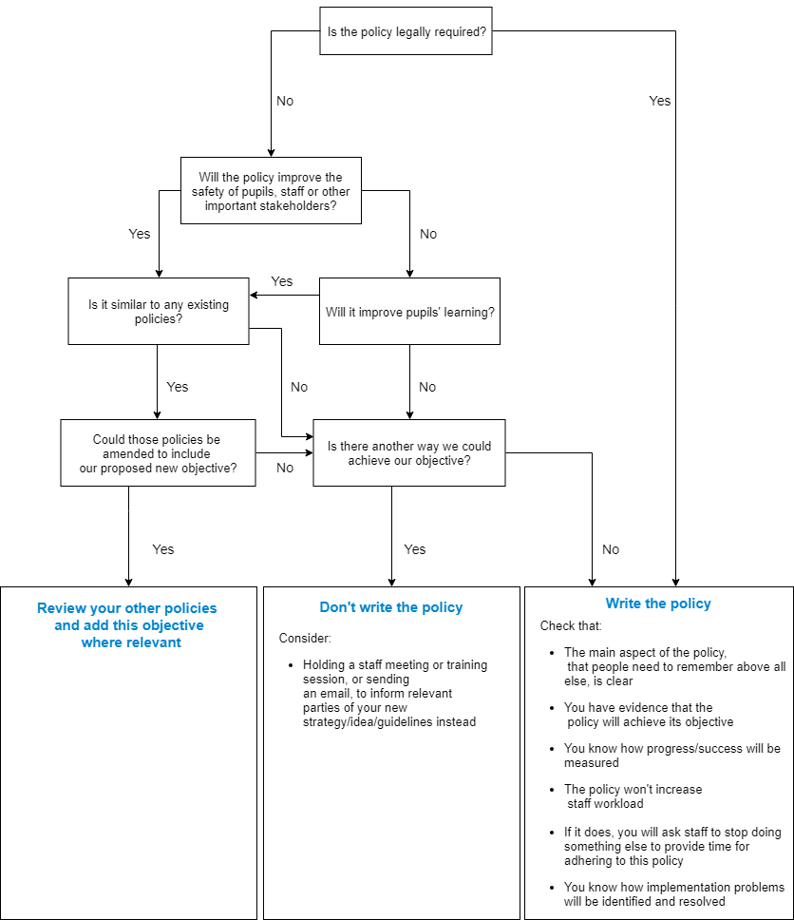
Ensuring staff have capacity to take on a new task is vital to its success and their wellbeing. Our aim is to put the joy back into teaching without compromising pupil outcomes:
Suggested Policy: XXX Policy

- Embedding consistency
- Yes
- Yes
- Yes
Summing Up & Judgement:
- Best Practice
- Accountability of FGB, staff, pupils
- Yes PfA
- Write Policy

“Any Critical Incident
Flow Charts: collate into
Incident Protocols
Folder, in Office”

